LESSON  Unit 6: Tradition and language | School:32
Date:24.01.2023 | Teacher name: Aslanova Ch.K.
Grade: 9 |  | Number absent:
Theme: Relationships
 | «How to form Wh-questions correctly?»
Learning objectives:
Lesson objectives: | All learners will be able to:  -talk about marriage in different countries and families  -learn making general and wh-questions;  -find specificinformation from the text;  Most learners will be able to:  --try to make the general and wh-questions;  -talk about marriage in different countries and families  -learn making general and wh-questions;  -find specificinformation from the text;  Some learners will be able to:  -understand how make wh-questions correctly  -Make their own questions according to the text.
Previous lesson | Relationship
Plan
Plan time | Plan activities | Resources
Beginning  5 min | Greetings  The teacher sets the lesson objectives, letting students know what to anticipate from the lesson.  Warm-up  Teacher uses method: Critical thinking  Students make a circle. Teacher throw a ball to one students and ask:  «How would you feel if your parents chose your future partner?»  Student think and answer. Then throw the ball to another student.
Middle  30 min  Language Focus | Students work in two groups. The first group read the text about Imran, the second group reads about Samina.  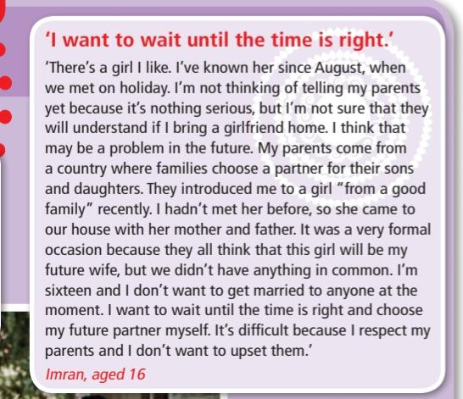    Teacher gives students some puzzles with questions. Students have to complete puzzles.    Teacher explains how form Wh-questions in English language and important thing is order.  Forming wh-questions  With an auxiliary verb  We usually form wh-questions with wh- + an auxiliary verb (be, do or have) + subject + main verb or with wh- + a modal verb + subject + main verb:  With teacher helping students try to make their own puzzle with Wh-questions. Teacher gives them cards with some words, which they must use.
Ending  Home work  Reflection | Students have to make one-puzzle question and present to their classmates  Traffic lights  Don' understand  Difficult  Understand

