Short- term plan
Lesson plan
Long-term plan: LESSON 39  Unit 4: Charities and Conflict |  |  |  | School: 20
Date: 30.11.2021 |  |  |  | Teacher name:  Kuzhamberlieva N.K.
Grade: 9 D |  |  |  | Number present: |  | absent:
Lesson title: Social problems
Learning objectives |  | 9.2.5.1 - recognize the opinion of the speaker(s) in unsupported extended talk on a wide range of general and curricular topics;  9.1.1.1- use speaking and listening skills to solve problems creatively and cooperatively in groups;  9.6.8.1 - use a variety of future forms, including some passives, on a range of familiar general and curricular topics;  9.1.2.1- use speaking and listening skills to provide sensitive feedback to peers;
Lesson objectives |  | All learners will be able to:  Listen and read for gist, read for specific information, use topic related vocabulary  Most learners will be able to:  Listen and read for gist, read for specific information, use topic related vocabulary, get an overview of a module,  Some learners will be able to:  Listen and read for gist, read for specific information, use vocabulary about charities and conflicts in different exercises
Assessment criteria |  | Learners have met the learning objective if they can: talk about charities and conflicts
Value links |  | Explore the themes of charity
Cross curricular links |  | Volunteering
ICT skills |  | Interactive board, PPT
Previous learning |  | Vocabulary “Earth and our place on it”
Plan
Planned timings  Start  2 min  3 min | Planned activities  Setting positive atmosphere by asking some ice breaking questions.  - Good morning students!  Active learning  Listen to three people talking about  What’s in this module?  Read the title of the module the problems below . Which is the most serious for each person? Why? |  |  |  |  |  | Resources
5 min  5 min  5 min  10 min. | Active learning  (W, I, f) Brainstorming “Adventure Travel”  Which two of these problems do you think are the most serious? What do we need to do? Why? The class votes for the three most serious ones.  Teacher ask referential questions to learners bearing on the theme  1. What types of charities do you think are doing the best and most effective work in the world?  2. What do you think about giving money to homeless people or beggars?  3. Do you think it is better to give time or money?  4. Do you think countries should help the poor in their own country before sending aid to other countries? Why?  Descriptor  A learner  - conveys ideas  - answers the questions and discusses it  F.A  Write about a Nobel Prize winner (who has made something prominent in his/her life).  (W, I) Teacher: Why do people give money to charities? Which charities are the most popular in your country?  F.A.  Task 1. Match the underlined words to their definitions. Think about the context of the words.  1. In 1939, Nazi Germany decided to invade Poland.  2. Britain and France were allies in World War II.  3. Approximately 300,000 Iraqi soldiers were wounded during the first Gulf War in 1991.  4. US president Kennedy sent troops to Vietnam in 1962.  5. North and South Korea agreed to a truce in 1953.  6. The conflict between Greece and Persia lasted about 50 years.  7. In 1914, an international crisis resulted in the outbreak of World War I.  8. The total number of casualties in World War I was over 37 million.  9. In Roman times, the sword was considered to be an effective weapon.  a. an agreement to stop fighting for a certain period of time  b. a strong disagreement or war  c. countries who are friends  d. enter a country by force  e. groups or individual soldiers  f. injured while fighting  g. people who are injured or killed during a war  h. something that is designed to cause harm or damage  i. the start of a war  Descriptor A learner  Task 1 predicts the meaning of new words and matches them with their definitions; |  |  |  |  |  | TPR  https://youtu.be/Ink2uvp--9c?t=4  Picture  https://youtu.be/JnYBvLY0GOg?t=23  Worksheet  Worksheet  Worksheet
Middle  10 min  3 min | Cоllоbarative learning - is an educational approach to teaching and learning that involves groups of learners working together to solve a problem, complete a task, or create a product  (W, P, I, f ) Pre-speaking  (1) Do you have a favourite charity?  (2) Are you satisfied with the work charities do?  (3) Do you think governments should do more to help charities?  (4) How often do you give money to charities?  (5) Have you ever received charity from others?  (6) Would you like to work for a charity?  (7) Do you worry about where the money you donate to charity goes?  (8) Do you think that one day there will be no need for charities?  (9) Do you agree with the expression “charity begins at home”?  (10) How much suffering would disappear if more people donated money to charity?  F.A. “Quick nod”  Teacher asks students if they understand nod yes or no.  Descriptor:  A learner  - talks about types of charity  - discusses and expresses his/her opinion  F.A. Active prompt  Do you agree or disagree with him/her?  Why do you think that? Persuade us!  Teacher asks factual questions according to the picture.  Discuss with your partner and talk about yourself.  Where?  When?  How?  With whom?  How long?  Descriptor:  A learner  - asks the questions  - expresses his/her opinion on the theme  F.A. by clapping  (W, P, I, f) Post – speaking - Writing  Task. Write a letter to a sponsor on behalf of All Hands Volunteers asking for help after a natural disaster.  Think about:  • Main information about your charity organization.  • Activities your organization is involved in.  • Problem your organization is faced.  • What help you need and give your reasons.  Descriptor  A learner  • includes all content points with appropriate expansion;  • follows the structure of a formal letter;  • organizes ideas clearly with suitable linking devices;  • uses present and past simple forms in active and passive in writing; |  |  |  |  |  | Worksheet  Worksheet  Worksheet
End  2 min  3 min | Evaluation:  Self – assessment: every learners assess themselves  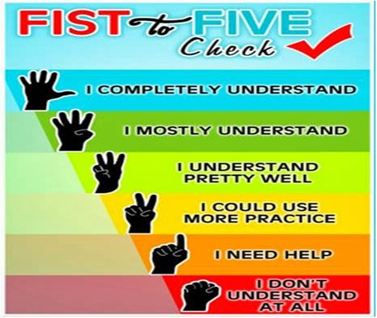  Feedback: “3-2-1”  3- facts known from the lesson  2- interesting things learned from the lesson  1 -question for the lesson  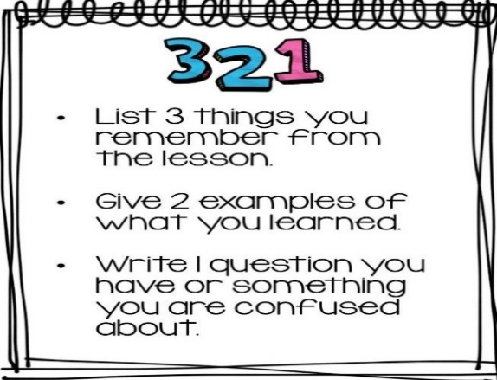
ADDITIONAL INFORMATION
Differentiation – how do you plan to give more support? How do you plan to challenge the more able learners? |  |  | Assessment – how are you planning to check learners’ learning? |  | Health and safety check
- challenge more able learners to come up with a strategy for effectively recording different types of vocabulary presented in this lesson |  |  | - check pronunciation of new words and reinforce with drilling where necessary |  | - ICT links  Values links
Reflection  Were the lesson objectives/learning objectives realistic?  Did I stick to timings?  What changes did I make from my plan and why? |  |  | Use the space below to reflect on your lesson. Answer the most relevant questions from the box on the left about your lesson

