Short term plan: term 3

School |  | Comprehensive Secondary school named after T.Musabaev
Unit: 5 Our Health |  | Lesson 49
Teacher name: |  | Yefremova N.Yu.
Date: |  | 08.01.26
Grade: 6A |  | Number present: | absent:
Lesson title | Our Health: Vocabulary: illnesses / ailments
Learning objectives | 6.1.9.1 use imagination to express thoughts, ideas, experiences and feelings  6.2.1.1 understand a sequence of supported classroom instructions  6.3.1.1 provide basic information about themselves and others at sentence level on an increasing range of general topics
Lesson objectives | Learners will be able to:  - present illnesses/ailments  - discuss illnesses/ailments
Value links | Family – Family values are moral and ethical principles of typical family life, including sacrificing for loved ones, putting your loved ones first, and keeping your loved ones at the centre of your thoughts and actions.
Value links | Instilling the value: Law and Order  Understanding the importance of law and order in ensuring the protection and safety of society  Value link: Law and Order
Basis: instructions of the Head of State K.Tokayev given at the II, III and IV sessions of the National Kurultai, Order No.123 of the Ministry of Education of the Republic of Kazakhstan
Plan

Stages / Time | Teachers actions | Students actions | Assessment criteria | Resources
Beginning of the lesson  Warming-up    3 min.  Pre-learning  «Brainstorming» method  7 min. | Organization moment:  1.Greeting.  Ask about the weather.  The teacher sets the lesson objectives, letting students know what to anticipate from the lesson.  Warming up  Where are you from?  How old are you?  What color is it?  How many students are there in class?  What day of the week today?  Lead – In   | The aim: To develop pupils speaking skills and create friendly atmosphere  Efficiency: By wishing each other they feel better and feel the support of others  Students of the class are listed.  Students’ attention is drawn to the lesson.  Students say different words from the picture  •Learners remember previous lesson vocabulary  •Learners answer the questions | The teacher to assess learners for their ability.  “Good job!  Well done!”  Formative Assessment    Good job!  Assessment criteria  make basic statements related to personal information, match places to continents | Pictures  worksheet  Picture
Middle of the lesson  Presentation part.  30 min | Ex:1 P:53  • Draw Ss' attention to the pictures. Play the recording. Ss listen and repeat chorally or individually. Elicit the L1 equivalents. DR  Ex: 2 P: 53  • Explain/Elicit the meanings of any unknown words and read out the example exchange, then Ss talk in pairs about the illnesses/ailments referring to the pictures and using the phrases.  Monitor the activity around the class and then ask some pairs to report back to the class.  Conclusion during the lesson some tasks differentiated by outcomes of the students and by their abilities. | • Learners listen and repeat. Say these words in your language  ANSWERS  Students own answer  • Learners discuss in pairs, as in the example. Answer the question  ANSWERS  1 A: What's wrong with Damir?  B: He's got a stomach ache.  2 A: What's wrong with Sanzhar?  B: He's got a cough.  3 A: What's wrong with Nurgul?  B: She's got a headache.  4 A: What's wrong with Ulan?  B: He's got a cold.  A: What's with Akbota?  B: She's got a temperature.  5 A: What's wrong with Kenje?  B: She's got a rash.  6 A: What's wrong with Mira?  B: She's got an earache. | Descriptor:  -Listen and repeat  - . Say the words in your language  Total: 2 point  Self assessment  Differentiation: «Verbal support» method is used to help Ss use new words in the sentences.  Descriptor:  - discuss in pairs,  - complete the task  Total: 6 point  -Make CCQ questions Yes / No |   Card  Worksheet  Students book
End of the lesson  5 min | FEEDBACK  Learners provide feedback on what they have learned at the lesson.  Home task:  Ex:2 p:36- complete the sentences | 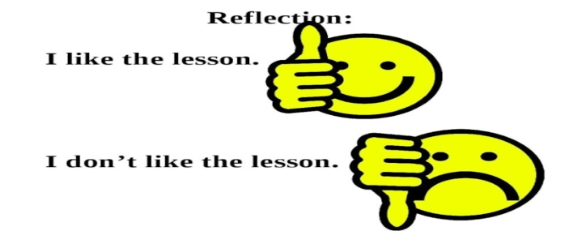 |  | Poster Success  

