Lesson plan
Unit: | Creativity
Name of the teacher | Satymbaeva Z.ZH
Date: | 01.02.2021
Class:5 A | Number of attendees:15 | Number of absent learners:
Topic | Musical instruments
Learning objective according to the curriculum | 5.2.1.1 understand a sequence of supported classroom instructions;  5.5.6.1 link, with some support, sentences into coherent paragraphs using basic connectors on a limited range of familiar general topics
Lesson objectives | All learners will be able to:  - Differentiate musical instruments;  - Answer the question;  - Make up questions according to the sample.  Most learners will be able to:  - Make up sentences using new words;  - Match words with pictures;  - Answer the questions.  Some learners will be able to:  - Choose the right option;  - Make up sentences using modal verbs;  - Prove the right answer.

Procedure
Lesson stage / Time | Teacher’s actions | Students’ actions | Assessment | Resources
I.Greeting2 min. | Good day students!  How are you today? What is the weather like today? | Greet teacher.  Answer the question. | Teacher’s approval
II.Brainstorming  3 min. (Zoom) | 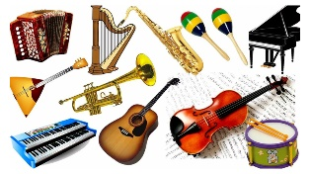  Look at the screen and try to guess what we are going to talk about.  Today we are going to talk about “Musical instruments”. | Learners try to guess the topic of the lesson. | Teacher’s approval (Excellent, good, think over…) | PPT
III.Presenting objectives  2 min. (Zoom) | Today you will be able to :  -Identify and learn the names of musical instruments;  -Revise modal verbs Could and Can;  -Answer the questions;  -Do some tasks. | Listen to the teacher. If they have questions, ask the teacher.
IV. Lead-in  5 min.(Zoom)  3min. (Zoom)  Middle  5 min.(Zoom)  3 min. (Zoom)  5 min. (Zoom)  End  2 min. (Zoom)  Асинхронно  10 min. (Off- line). | Presenting new words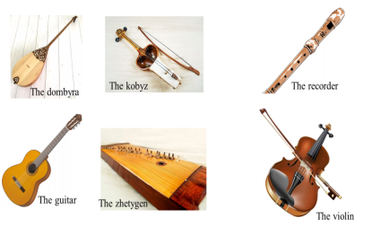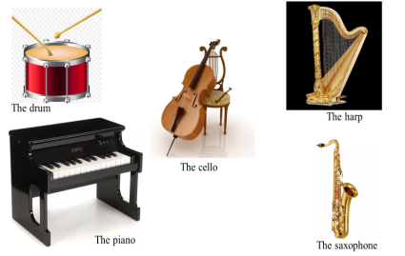  Task 1 “Guessing”  Learners should listen to some music and guess what musical instrument was played.  - The dombra  - The kobyz  - The zhetygen  - The violin  - The guitar  - The recorder  - The drum  - The piano  - The harp  - The saxophone.  Task 2 “Matching”  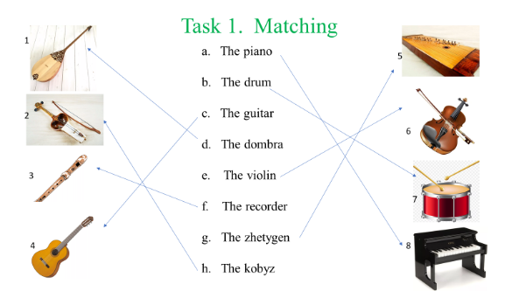  Learners should match pictures with the names of the musical instruments. Each right answer is I point.  Descriptor  A learner:  - match the pictures with the words.  Revision  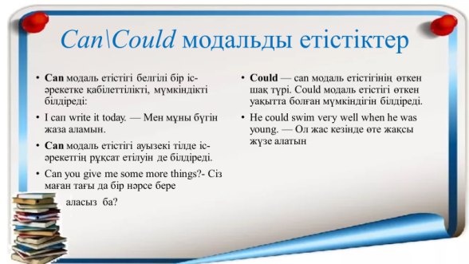  Making up examples,  - Now I can (can’t)……..  - When I was 3 years old I could (couldn’t)……  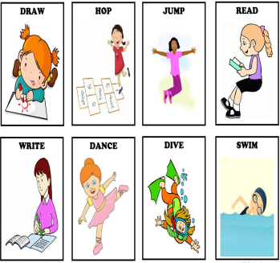  3 task  “Fill in the gaps”  Learners should fill in the gaps with the appropriate musical instrument.  Descriptors:  -Each sentence is the description of a person on the picture.  - Students should read the sentence and find a person on the picture.  - Define what the musical instrument the person plays.  Summarizing the lesson  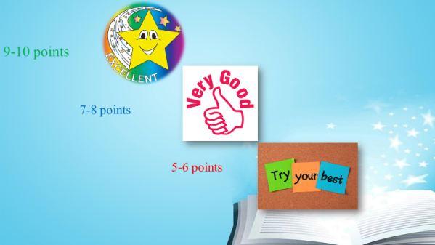  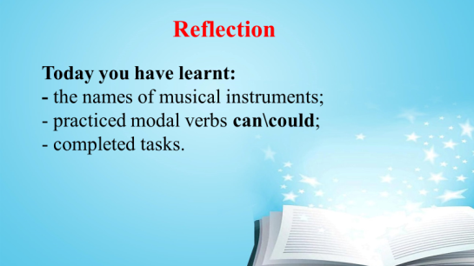  At the end of the lesson the teacher announces the results of the learners’ works by points.  Reflection:  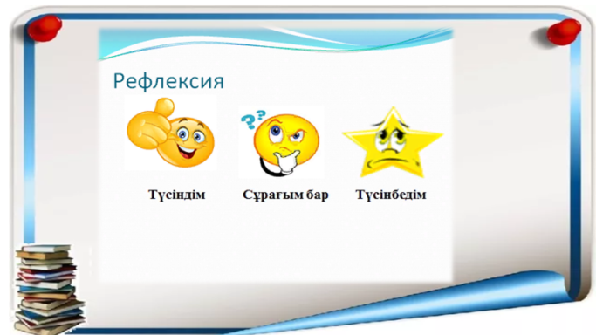 | Learners read and write new words in the vocabularies.  Learners listen to the music and guess the instrument which was played.  Learners match pictures with the names of the musical instruments.  Learners make up question following the criteria. Try to answer the question.  Learners revise modal verbs Can\Could. Make some notes in their copy-books.  C- make up sentences using the modals and conjunctions.  B- make up sentences according to the examples and use other words.  A-follow the sample and use verbs from the table.  Students read the description of a person and find him. Then they should define what instrument the person plays.  Learners sum up their points and share with their results.  Students write their results and emotions on a sheet of paper and then send it to the teacher. | Teacher’s approval (Excellent, good, think over…)  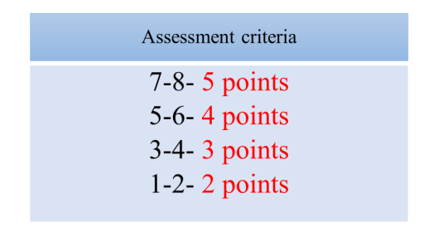  Self-evaluation. Learners check their answers and evaluate themselves according to the criteria.  Teacher’s approval (Excellent, good, think over…)  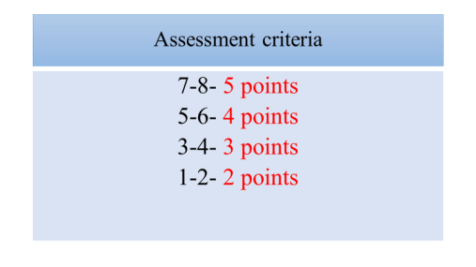  Self-evaluation. Learners check their answers and evaluate themselves according to the criteria.  9-10- Excellent  7-8- Very good  5-6 (less)- you should try your best. | PPT  PTT  PPT  PTT

