КГП на ПХВ «Педагогический высший колледж имени Б.Ахметова»

(наименование организации образования)

**План учебного занятия**

"THE ANT AND THE GRASSHOPPER " BY W. S. MAUGHAM

(тема занятия)

Наименование модуля /дисциплины: ПМ-02 Домашнее чтение

Подготовил педагог: Муканова Б. Т.

"14 " ноября 2023 года

**1. Общие сведения**

**Курс, группа**: 4 курс, группа ИЯ-42

**Тип занятия:** комбинированный, урок применения ЗУН

**2. Цели:**

- создать условия для активизации изучаемой лексики;

- развития навыков чтения и устной речи;

- формирования умения анализировать художественные произведения;

**Задачи:**

- расширение словарного запаса и совершенствование навыков чтения и устной речи.

**3. Ожидаемые результаты:** обучающиеся знают лексику урока и умеют применять ее в речи; умеют излагать известную информацию; умеют выражать свою точку зрения и аргументировать ее.

**4. Необходимые ресурсы:** смарт ТВ, интернет ресурсы, карточки, листы оценивания, маркеры.

**5. Ход занятия**

|  |  |  |  |  |
| --- | --- | --- | --- | --- |
| **Planned timings** | **Teacher’s activities** | **Student’s activities** | **Evaluation** | **Resources** |
| **Beginning**  5 min. | **Organization moment :**  **Activity 1.Greeting.**  T gives them different pieces of pictures of the ant , grasshopper and butterfly and divide into 3groups.  **Activity 2. Warming-up**  Some quotes about reading are used to make S interested in learning process. | Students greet a teacher and divide themselves into three groups taking pictures of the ant , grasshopper and butterfly .  Theу watch and discuss popular quotes about reading and books | ***«The praise»*** method is used to evaluate Ss with phrases like:“Good job! Well done!” | Envelop with pieces of pictures  <https://youtu.be/BV2ebCoE0Kw> |
| **Middle**  5 min  5 min | **Activity 3.Checking the home task.**  «Footprints in the jungle» by W.S. Maugham | « Footprints in the jungle» by W. S. Maugham | Group assessment Correct retelling (without gross grammatical errors) with detailed content – ​​10 points | Student’s copy- books |
| **Activity 4.Pre- Reading activity**  **Task 1. introduction of the new words** . Teacher opens Quizzes and asks students to match new phrases with their definition to the text | Students match new phrases with their definition to the text | Verbal assessment ***«The praise»*** method.  Group assesment One correct phrase is one point. | <https://wordwall.net/ru/resource/63638995>  **Appendix 1** |
| 10 min | **Activity 5.While- Reading activity**  Now let us read the text and make up story map giving details . («The Ant and the grasshopper » by W S Maugham ) –group work | Students make up story map giving details using the text «The Ant and the grasshopper» by W S Maugham ) and present it to groupmates. | Peer assessment:  (groups evaluate each other)  Correctly pronunciation (without gross phonetic errors) with detailed content – ​​10 points | Sheet of paper and **Appendix 2** |
| 10 min | **Activity 6. Post - reading activity**  Read and complete six sentences using new words and word combinations. | Students complete six sentences using new words and word combinations7 | Group assessment If it corresponds to the content and the correct choice of vocabulary - 10 points | Sheet of papers or posters  **Appendix 3** |
| 5 min | **Activity 7. Task for formative assessment**  **Answer the question in your own words**  1. How do you understand the expression «Black sheep» Why is it applied to Tom?  2. How did he spent his life?  3. Why did George give Tom large sums of money not once?  4. Why did Tom do with money ?  5. In what way and why did Tom blackmail his brother George ? | Students answer the question based on information in the text individually. | Verbal assessment | Student’s Book «Short stories to read and discuss». |
| **End**  5 min    Reflection  Home work: | **Activity 8. Self-assessment card “Now I can..”**  Teacher gives the students charts with questions for competence assessment. | Ss fill the card giving feedback of the lesson. | T evaluates everyone and encourages S with praise phrases. | Self-assessment card “Now I can..” |
| Open your diaries and write down your home work/  Сhoose one of the tasks and get ready for speaking:  1)Make up Venn’s diagram to compare the lifestyle of 2 brothers. Get ready for discussion.  2) Retell fhe story on the part of George or Tom.  The lesson is over/ Good bye . | Ss. open the diaries and write down their home work  -Make up Venn’s diagram to compare the lifestyle of 2 brothers. Get ready for discussion. |  | Student’s diaries |

**Appendix 1**

**Match new phrases with their definition to the text**

make smb do smth, in spite of smth, cause trouble, borrow smth from smb, turn to smb for smth, wash one's hands of smb (smth), be upset, burst into laughter (tears) a black sheep, to blackmail, to gamble

**Appendix 2**

**Make up mind map giving details based on the text «The Ant and the grasshopper» by W S Maugham and present it to groupmates.**

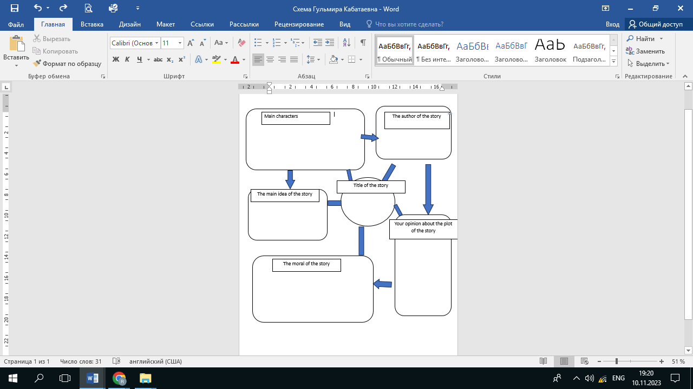

**Appendix 3**

**Complete the following sentences.**

1. I suppose every family has **a black sheep.**

2.  But when George washed his hands of him, Tom began to **blackmail** him.

3. George was very much **upset** when Tom blackmailed him.

4. I **burst into laughter** as I looked at George's face, I nearly fell on the floor.

5. For twenty years Tom **gambled,** danced, ate in the most expensive restau-rants and dressed beautifully.

6. They soon found out: he **borrowed** money from other people.

**Appendix 4. Task for formative assessment**

**Answer the question in your own words**

|  |  |
| --- | --- |
| 1. How do you understand the expression «Black sheep» Why is it applied to Tom? |  |
| 2. How did he spent his life? |  |
| 3. Why did George give Tom large sums of money not once? |  |
| 4. Why did Tom do with money ? |  |
| 5. In what way and why did Tom blackmail his brother George ? |  |