Term 3  Unit 5 "Reading for pleasure" |  |  | School-gymnasium № 77
Date: 22.01.2020 |  |  | Teacher name: Zhalelova I.
Grade 9 «Б» |  |  | Number present: |  | Number absent:
Theme of the lesson: |  |  | Books and films.
Learning objectives that this lesson is contributing to |  | 9.4.4.1 read a range of extended fiction and non-fiction texts on familiar and unfamiliar general and curricular topics  9.4.5.1 deduce meaning from context in extended texts on a range of familiar general and curricular topics  9.3.4.1 respond with growing flexibility at both sentence and discourse level to unexpected comments on a range of general and curricular topics
Lesson objectives |  | All learners will be able to:
- recognize and understand vocabulary of books and film genres, key phrases about likes and dislikes.
- answer simple questions on the topic.
- to speak about books and films in their life
 |  | Most learners will be able to:
- to speak about books and films (genres)
- make dialogues between them on the topic
- use passive forms in sentences
 |  | Some learners will be able to:
- produce extended sentences talking about likes and dislikes.
- describe their favourite books or films.
Language objectives |  | Focus on speaking
Value links |  | Appreciation the art of literature.
Cross curricular links |  | Literature, Art.
Previous learning |  | Passive voice,
Use of ICT |  | Smart board for showing a presentation, getting additional information, PPT
Plan
Planned timings | Planned activities |  |  | Resources |  | Assessment criteria
Beginning the lesson  2 min.  5 min.  2 min | Greeting.  Org.moment  Warm up.  1. Psychological atmosphere: All learners will turn to each other and say their wishes:  2. Division into groups using sweets (2 or 3 groups)  3. Checking the home task. (Exercise 1 p.42) |  |  | Flower  Workbook  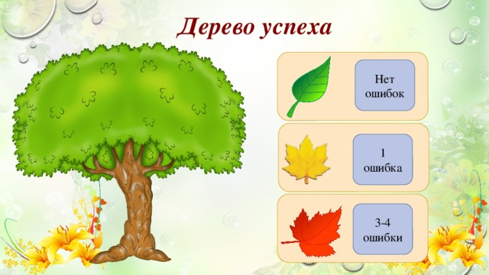 |  | Homework Assessment Criteria  (Үй тапсырмасын бағалау критериі)  - Rewrite the sentences in the Passive.  - Grammar accuracy.
Main part  Introduction of the new theme  5 min.  3 min.  10 min.  3 min.  5 min.  3 min. | Teacher shows slides with pictures and the video on screen, and then asks students to guess the theme of the lesson, afterwards name it.  The teacher sets the lesson objectives, letting students know what to anticipate from the lesson.  Start thinking. Answer the questions.  1. What is shown in the picture?  2. Do you like reading?  3. Have you ever read a book in Kazakh?  2. What genres do you know?  3. Do you like watching films?  Presentation of the new words concerning with the topic.  Group work.  1. Task. Discussion. Teacher gives questions to each group.  2. Have a rest. (Сергіту сәті)  “Catch and answer”  (қағып алда жауап бер)  3. Pair work. Make up a dialogue.  4. Group work. Fill in the semantic card |  |  | PPT  PPT  The black box method is used.
Ending the lesson  5 min.  3 min. | Home task. Write an essay on theme: «My favourite book»  Feedback.  Reflection. |  |  | Edward De Bono’s Six Thinking Hats  Ladder of success
End  1min | Feedback: Teacher asks students what task was difficult to them and which pair worked well.
Additional information

