Unit 6:  Reading for Pleasure |  | School: Umbetaly
Teacher name: |  | Smagul Zh.A
Date: |  | 04.02.25
Grade: 5 |  | Number present: | absent:
Lesson title | Types of literature
Learning objectives | 5.3.2.1 ask simple questions to get information about a limited range of general topics  5.3.7.1 use appropriate subject-specific vocabulary and syntax to talk about a limited range of general topics  5.5.3.1 write with support factual descriptions at text level which describe people, places and objects
Lesson objectives | Ask simple question to get information  Use new vocabulary answer the questions  Describe types of books
Plan

Stages / Time | Teachers’ actions | Students’ actions | Assessment criteria | Resources
Start | Organization moment  1.Greeting.  Ask about the weather.  Warm-up  • Books closed. Ask the students, in their own language, if they know rooms. Elicit the names of these rooms. You could put them on the board.  • Ask the class if they know the names of these houses’ room in English. Elicit any names they give you and put them on the board. Lead – In  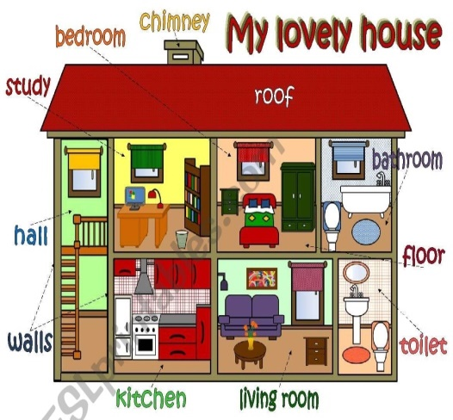 | The aim: To develop Ss speaking skills and create friendly atmosphere  ‘.Efficiency: By telling the wishes they show their appreciations .  Students say the rooms name in L1 | At the organization moment T tries to award active Ss. «The praise» method is used to evaluate Ss with phrases like:  “Good job!  Well done!”  Formative Assessment    Good job!  Assessment criteria  - Introduce themselves and tell about their friends house | Pictures  PPT  Student’s book
Main part | Ex: 11 p: 6  • To present the days of the week; to consolidate new vocabulary through translation.  • Students to repeat chorally or individually.  • Ask students to say the days in their in L1  • Ask students which days are the weekend  Ex: 13 p: 8  • to learn common phrases used in the classroom to consolidate through translation.  • Draw students’ attention to the pictures. Explain that each item is an instruction A teacher would say in the classroom?  Ex: 1 P: 9  •To present vocabulary for rooms  Play the recording. Students listen and repeat chorally or individually.  •Draw students’ attention to the pictures and elicit which room is which.  Ex: 2 P: 9  •To present/practise vocabulary related to furniture  •Play the next recording. Students listen and repeat chorally or individually. Elicit the L1 equivalents from various Ss.  •Explain the task and read out the headings, translating them if necessary. Read the example sentences aloud and then students work in closed pairs and write the words under the headings and make sentences of their own. Ask various learners around the class to read their sentences aloud.  Conclusion during the lesson some tasks differentiated by outcomes of the students and by their abilities. | Learners listen and repeat. What are these words in your language?  ANSWERS  Students’ own answer  Learners listen and repeat. Say these sentences in your language.  ANSWERS  Students’ own answers  Learners listen and repeat. Match the rooms to the pictures.  ANSWERS  1 kitchen  2 living room  3 bedroom  4 bathroom  5 hall  Learners listen and repeat. What re these words in your language?  ANSWERS  Students’ own answers  Learners identify these words. Which words can go under these headings.  ANSWERS  Rooms: bedroom, living room, hall, bathroom, kitchen  Furniture: bedside, cabinet, bed, sofa, cupboards.  Other: cooker, think, toilet, mirror, pillow | Descriptor:  - present the days of the week  Total point: 1  Differentiation:  «Verbal support» method is used to help Students use new words in the text.  Make CCQ questions  Descriptor:  - listen and repeat.  Total point: 1  Descriptor:  - listen and repeat chorally or individually  Total point: 1  Descriptor:  - listen and repeat chorally or individually  Total point: 1 | Cards  Worksheets
End | Home task:  Ex: 3 P: 6 WB | 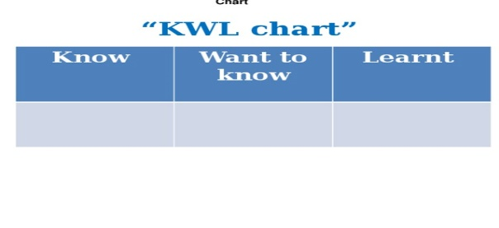 | Students use their stickers to show their knowledge according to the lesson. | Poster Success Ladder.

