Lesson plan

Unit 2 “Holidays and Travel” |  |  |  | School: School-lyceum №60
Date: 06.04.2021 |  |  |  | Teacher name: G.T. Tyulyubayeva
Grade: 7 |  |  |  | Number present: | absent:
Lesson title |  | The best places to visit in Kazakhstan.
Learning  objective(s) that  this lesson is contributing to: |  | 7.R2 understand specific information and detail in texts on a range of general and curricular topics  7.S3 give an opinion at discourse level on a growing range of general and some curricular topics
Lesson objectives |  | All learners will be able to  - identify the details of the text about Kazakhstan top five places to travel and answer the questions  - share their opinion on best places in Kazakhstan in poster presentation and group work
Most learners will be able to
- write some sentences about cities they visited
Some learners will be able to
- share each other about their experience, visiting places in Kazakhstan
Assessment criteria |  | - recognize particular information and details about the best places in KZ  - share opinion on best places of Kazakhstan in group to present poster  - share opinion on tourist attractions in Kazakhstan to each other in whole group activity
Values links |  | to be proud of the best places of KZ to visit
Cross-curricular links |  | Geography, History
Previous learning |  | Students know and apply Present Continuous and Present Simple and Holidays vocabulary.
Plan
Planned timings | Planned activities |  |  |  |  |  | Resources
Start  Warming up 3 min | - Greeting: The teacher greets students, students take their places  The students are divided into pairs to fill in Venn Diagram about holidays in KZ and GB.  Nauryz  1 May New  Day of Victory Year 1st President Day8March  Independence Day  Christmas  Boxing Day  Easter  Mother’s Day  The teacher introduces the objectives of today's lesson and assessment criteria |  |  |  |  |  | Flash cards with the names of holidays
Middle  3 min  5 min  7 min  5 min  5 min  5 min  5 min | G/W 1. Task Pre-reading task:  More able learners: -activate the vocabulary -predict the story Less able learners: -find and name the words Descriptor a learner:  -reads active vocabulary -uses the words in speech  “Wordplay” activity The learners are divided into 3 teams. The teacher gives the task to write as many words as possible from the text and try to give their definitions, having read the text. A list of words: cultural heritage, natural wonder, sightseeing, resorts, unique, modern, recreation, magical.  Feedback: students check how many words are written, their spelling and their definitions (more able learners). I/W 2. Task While-reading task  1. What are 5 top places to visit in Kazakhstan? 2. Name 3 resorts of Almaty. 3. What is the population of Almaty?  4. Who built Astana? 5. What Mausoleum in Turkistan was dedicated to Sufi philosopher and poet? 6. When was Altyn Emel National Park established? 7. What area does the National Park cover? 8. How does Charyn Canyon look like? 9. What is Charyn Canyon's impressive size in length? 10.Where are Kolsai and Kaiyndy Lakes situated?  Descriptor a learner:  - reads the text  - answers the questions (10 questions)  Peer feedback: students exchange their works and check them, using the keys. The teacher observes and helps if it is necessary.  “Making a poster” creative activity There are 3 groups, each of them should make a poster of their best places to visit and tell their opinions about them.  Peer-assessment The students assess the work of their opponents, filling in the assessment tick-paper. Teacher observes students' work.  P/W 3. Task Post-reading task Substitution: Straight Face (2 students sit in front of each other and ask the questions on the text).  More able learners will be given a task to tell their own topic about picturesque places of Kazakhstan  Less able learners will be given more support by given them  Key words: visit, go, walk, have a rest, spend a good time with just to make up simple sentences.  Peer-assessment The students assess each other. The teacher is an observer. G/W 4. Task Role-play/ Tourist guide Descriptor a learner:  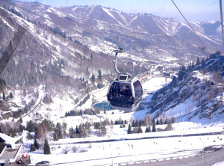  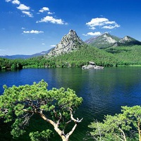  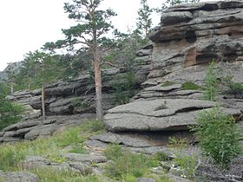  - acts out the role-play  - gives opinions about the visited places to the tourists about 3 resorts  - presents their posters/postcards to the class  Group- assessment Each group assesses opponents' achievements, listening to their role-plays and comments. Teacher is an observer.  - G/W 5. Task “Conversation circles” activity The students stand in 2 circles: inner and outside ones. The pairs of students of both circles stand looking at each other. The teacher gives the students cards ''The best tourist attractions'' to the students of the inner circle. Then each speaker should tell his/her partner about the top place. After a while, the teacher claps and the outside circle moves until the next clap. In the end all the representatives of the outside circle can tell about the best places of Kazakhstan fluently. Overall, the activity's aim to inform each participant about the best places to visit in Kazakhstan.  Descriptor a learner: - speaks on the best tourist attractions (individual work) - shares the opinions about given information about the best places to travel in Kazakhstan (pair work) Teacher assesses the work, observing the learners' answers and doing the corrections. |  |  |  |  |  | Pictures of the best places of Kazakhstan
End 2 min | Self-assessment: writing letter reflection  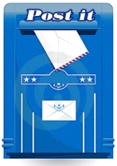Ask students to look at lesson objectives they set at the beginning of the lesson and think and say what they did well in the lesson and what needs improvement.  - What have I learnt?  - What have I found easy?  - What have I found difficult?  - What do I want to know? |  |  |  |  |  | Post  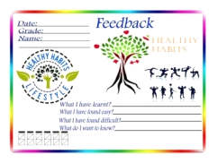Letter stickers
Additional information
Differentiation – how do you plan to give more support? How do you plan to challenge the more able learners? |  |  | Assessment – how are you planning to check  Learner’s learning?
Differentiation by outcome: more able learners will be given a task to write 5-7 sentences about the cities, visited by them, to share their experience about places to visit in Kazakhstan in making posters and role-play.  Differentiation by support: less able learners will be given more support to find and name active vocabulary, by given them key words:have a rest, spend a good time with ... to make up simple sentences, to draw in making a poster. |  |  | Self-assessment - students evaluate their own work, identifying their own skill gaps, where their knowledge is weak. Teacher's assessment- teacher assesses the work of the students, doing the corrections. Peer-assessment- students evaluate the peers' work and give the feedback on the quality of their work.
Reflection
Were the lesson objectives/learning objectives realistic?
Did all the learners achieve the lesson objectives/ learning objectives? If not, why?
Did my planned differentiation work well?
Did I stick to timings?
What changes did I make from my plan and why?
Summary evaluation
What two things went really well (consider both teaching and learning)?
1:
2:
What two things would have improved the lesson (consider both teaching and learning)?
1:
2:
What have I learned from this lesson about the class or individuals that will inform my next lesson?

