Subject | English
Date | 12.01.2021
Grade | 2
Theme | - Our body
Learning objectives | 2.S3 use a limited range of basic words, phrases and short sentences to describe objects, activities and classroom routines  2.R1 read and spell out words for others  2.UE6 use demonstrative pronouns this, these, that, those to make and respond to requests for information

The lesson | Teacher’s actions | Pupils’ actions | Assessment
- Organizational moment.  • The greeting.  • The aims of the lesson.  Watch the short video. And say what is the lesson about.  The link on the video: https://www.youtube.com/watch?v=hD1kDoXuvws  2. Speech warming-up.  • Answer the questions.  What is your name?  How old are you?  Where are you from? | - Greets children  - Asks questions  - Asks questions | - Greet teacher  - Answer the questions  - Answer the questions | Teacher’s comments
- The introduction of the lexis.  - Listen to the teacher two times.  - Reading of the words in chorus  - Match the pictures and its translation.  hair волосы  ear ухо  eye глаз  nose нос  mouth рот  body тело  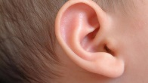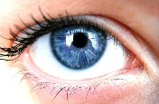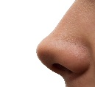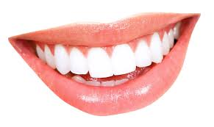  - The fixation of the lexis  - Activity book p.36 ex.1 – find and circle. Then draw the lines and write.  - The physical minute  - Look  - Repeat with the speed high and higher  Head, shoulders  Neese and toes  Neese and toes  Head, shoulders  Neese and toes  Neese and toes  Eyes, ears, mouth and nose  - The fixation of new lexis.  - Put the parts of the body in the right place and name them, match it with the words  Ex. 1 p.60  - Look at the picture teacher shows you. Put the letters of this word in the correct order and write down the words.  - Reading of the words individually and in chorus  Eey - eye  Aihr - hair  Eons - nose  Ouhmt - mouth  Are - ear | Read the words and shows the pictures  Explains the task  Corrects mistakes  Says the words and shows the movements  Explains the task  Corrects mistakes  Shows the pictures | Repeat the words.  Match the words and the pictures.  Find, circle, draw lines and write the words  Repeat the movements and the words after the teacher  Look, read and match  Write the words  Read | Teacher’s comments  Finger up  Teacher’s comment
- Home task: learn the words, AB p.36 ex.2 – read and colour  - Reflection. Self-assessment: Smiles - cards | Explains the task  Explains the task.  Gives cards | Write down the home-task  Show the card that assess their work at the lesson

