LESSON 38: Unit 5 Travel  Рrepositions- on, in, under, next to, in front of, behind |  |  | School: № 17
Date: 3.02.2022 |  |  | Teacher name: Suliyeva Milana
Grade: 1 |  |  | Number present: 9 |  |  | absent: 1
Learning objectives |  | 1.S3 pronounce basic words and expressions intelligibly  1.L3 recognise with support simple greetings  recognise the spoken form of a limited range of basic and everyday classroom words  1.UE14 use basic prepositions of location and position in next to on to to describe where people and things are  1.UE5 use interrogative pronouns which, what, where, how to ask basic questions  1.UE8 use simple imperative forms [positive] for basic commands or instructions
Lesson objectives |  | All learners will be able to:  Recognize simple greetings  Recognize Teacher’s instructions  Most learners will be able to:  Listen & draw some information in their picture according to the information they are given  Some learners will be able to:  Ask Questions “Where’s the ...” without mistakes
Previous learning |  | Where is it?
Plan
Planned timings | Planned activities |  |  | Learners’ activities | Evaluation |  | Resources
Beginning  10 min | Greeting  Teacher: Good morning, dear boys and girls!  Good morning, good morning!  Good morning to you!  Good morning, dear children!  I am glad to see you!  T: I’m glad to see you, too. How are you?  T: I’m fine too, thank you. Sit down, please.  Teacher demonstrates and drills basic prepositions of place: next to, in front of, behind using visuals at board.  Teacher projects images which learners have to scan to identify a detail and answer Teacher’s question e.g. Where’s the …? Learners shout out e.g. Under the …. |  |  | Pupils: Good morning, good morning!  Good morning to you!  Good morning, dear teacher!  We are glad to see you!  P-s: We’re fine, thanks and how are you?  Pupils answer the questions
Middle  15mins | Introducing new material  Teacher nominates one learner per group for each round and gives Total Physical Response instructions for learners who start on chairs in front of the class to follow e.g. Stand behind your chair and put your pen on your chair.  Learners are given a picture [picture A and picture B]. Learners ask e.g. Where’s the car? and draw information in their picture according to the information they are given. |  |  | First pupil completes each round’s instructions, wins a point for his/her team.
10mins | FORMATIVE ASSESSMENT  Draw the ball where you think…  1.The ball is ON the chair.  2. The ball is IN the box.  3. The ball is UNDER the desk.  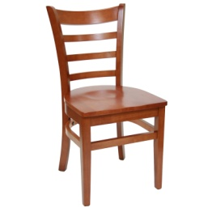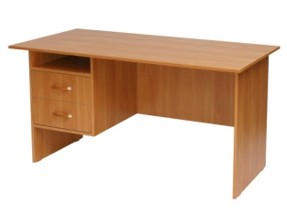 |  |  | Worksheets
End  5min | RELAXATION  5 stars - Green planet - I can do this.  4 stars - Yellow planet - I am getting there.  3 stars - Red planet - I need help.  I think you coped with the tasks perfectly.  -Let’s sing a “Good bye” song  THE LESSON IS OVER.GOOD BYE. |  |  | Pupils put their rackets on one of the planet.

