Short - term plan
Long-term plan unit: Unit 5. Our health |  |  | School: Akkol secondary school #3 named after Zh.Bekturov
Date: 20.01.20 |  |  | Teacher’s name: Murzakhanova A.K.
Class: 6th |  |  | Number present: 20 | Absent:
Theme of the lesson: |  | Countable and uncountable nouns: a/an, the, some, any, much, many, a lot of.
Learning objectives(s) that this lesson is contributing to |  | 6.C1 use speaking and listening skills to solve problems creatively and cooperatively in groups  6.UE use quantifiers many, much, a lot of, a few on a limited range of familiar general and curricular topics.  6.S6 communicate meaning clearly at sentence level during, pair, group and whole class exchanges
Lesson objectives |  | All learners will be able to:  - explain the difference between countable and uncountable nouns  - use quantifiers many, much, a lot of, a few on a limited range of familiar general and curricular topics  - use them correctly in a sentence  Most learners will be able to:  - use imagination to express thoughts, ideas, experiences and feelings  -use appropriate countable and uncountable nouns, including describing things  -ask simple questions to get information of general topics  Some learners will be able to:  -describe times and location, on a curricular topics  -give an opinion at sentence level
Assessment criteria |  | - A learner can give examples of using countable and uncountable nouns  - A learner can use many, much, a lot of, a few  - A learner can use the topic at sentences during class exchanges
Value links |  | The students work in collaboration in groups and respect each other’s opinions and view.
ICT skills |  | Smart board for PPT
Health and safety |  | Everyday classroom precaustions
Previous learning
Plan
Planned timings | Planned activities |  |  |  | Resources
Start  0-3 min  3-7 min | Class routine  Greetings  Teacher greets learners.  - Good morning, dear students! Sit down please.  - I’m glad to see you today! Teacher takes the ball and tries to find out the learners’ feelings at the beginning of the lesson. Then teacher asks students about weather, date, day, etc with the ball.  T: Students, I want to ask you some questions with the ball. You have to answer the questions:  - How are you today Bekarys?  - How is your mood today Ali?  - What is the weather like today Adiya?  - What date is it today Saniya?  - What day of the week today Imangali?  - What month is it now Alisher?  - Okey guys, thank you. Now I want to divide you in 4 goups. But at the first you have to count 1,2,3,4.  - The 1st numbers sit at desk number 1. The 2nd numbers sit at desk number 2. The 3rd numbers sit at desk number 3. The 4th numbers sit at desk number 4.  - I wish you success at this lesson today. Let’s start our lesson.  STARTER  Warm-up  Teacher prepares learners for Warm-up. Teacher gives instruction to look at the picture.  - Let’s see a video.  After video the learners to guess and the teacher show the picture with actions and ask questions. The learners have to guess the title of theme.  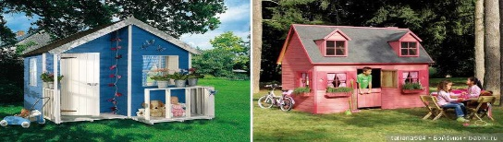  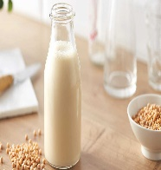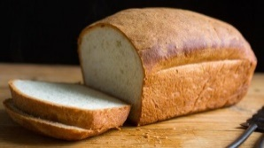  T: Dear learners tell me please:  - What is the rule?  - What the theme of our lesson?  Descriptor: A learner:  - follows instructions attentively  - makes sentences and develops the answers of question  (f) Oral assessment: Teacher assesses the learners orally with these words:  T:  - Excellent!  - Good!  - Fine! |  |  |  | PPT  Slide 1    PPT  Slide 2  https://www.youtube.com/watch?v=Op2M9NAgE_k  PPT  Slide 3
Middle  7-10 min  10-12 min  12-14 min  14-15 min  15-20 min  20-35  min | INTRODUCTION  Lesson objectives presentation  Teacher introduces with the lesson objectives presentation on the interactive board. Then teacher tells about new theme “Countable and uncountable nouns: a/an, the, some, any, much, many, a lot of ”,  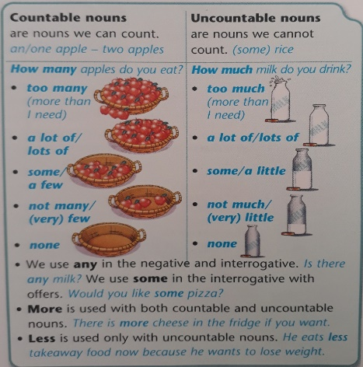  Also they will learn introduction of new material on the theme. They start the new theme. Students open their copybooks, write down the date and the theme.  DEVELOPMENT  Task 1  Teacher gives the pictures with food for every group:  - Now I give the pictures with food.  - The 1st group finds healthy food.  - The 2nd group finds unhealthy food.  - The 3rd group finds countable nouns.  - The 4th group finds uncountable nouns.  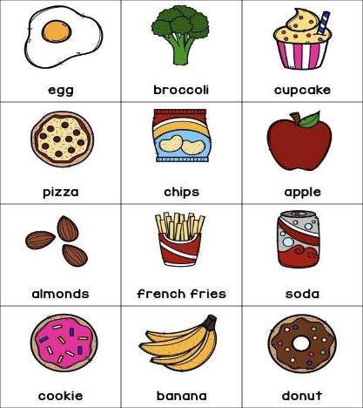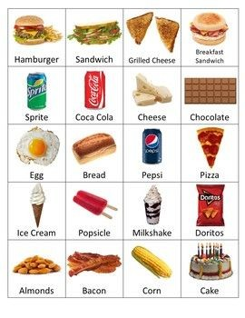  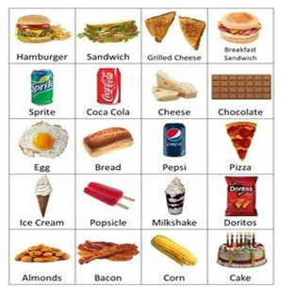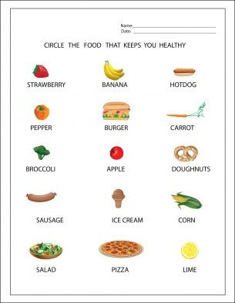  Descriptor: A learner  - identifies the types of nouns  - recognizes his or her ideas during group work  - expands his or her ideas with reasons when speaking and cooperatively in groups  (f) Assessment by smiles:    Try better! Not bad! Good!  Task 2  Fill in a/an or some. Then mark the nouns as C(countable) or U(uncountable)  - an egg – C  - some rice – U  - some cheese – U  - a biscuit – C  - an apple – C  - a banana – C  - a sandwich – C  - an ice-cream  - some milk – U  - some sugar – U  Descriptor: A learner  - uses quantifies a/an, some on a limited range of familiar general and curricular topics.  (f) Applause assessment:  Teacher assesses the learners with applause:    DYNAMIC BREAK  T: Let’s relax.  - Let’s relax  - -stand up  - -hands up  - -wave your hands  - -move your fingers  - -hands down  - -hands on hips  - -sit down  Task 3  Teacher shows to students 4 colors: red, green, blue and pink. Students choose one color and must sit at desk with this color. Example: the 1st desk is pink, the 2nd desk is green, the 3rd desk is blue, the 4 th desk is red.  T: Our the next task in bilimland.kz  Students work with test-tasks of bilimland.kz. They should choose the correct variant and answer quickly.  Descriptor: A learner  - manages the tasks without teacher’s support during listening  - create complex sentences  - argues about describing of countable and uncountable nouns  (f) Big thumb assessment:  Not bad! Good work! Try better!    Task 4  Reading the text. Students read the text and make up questions then answer the question correctly.  To be or not healthy  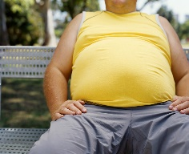  Fat Freddy is a very unhealthy man. Last year he won the lottery so now he doesn’t need to go to work. His daily routine is something like this: he gets up at about 11:30 a.m. and for his breakfast he eats chips, sausage, pizza, sandwiches, hamburgers, ice-cream, chocolate. After breakfast, he sits in his Rolls Royce and watches TV until 1 o’clock. Then he goes in the car to the pub, which is 400 metres away from his house. In the pub, he drinks a lot of beer, coca-cola, fanta, sprite, pepsi and sugary drink and usually eats a sandwich. When the pub closes at 5 p.m., his chauffeur drives him to the cinema. He watches films until 8 o’clock. In addition, his weight is 102 kg now that affects negatively on his reproductive potential. Freddy doesn’t have a family because his habits cause serious health problems. He wants to change his life, but he doesn’t know how.  How many __________ does he eat?  How much __________he drink?  He eats a lot of humburgers.  He drinks a lots of sugary drinks.  T: This man looks very unhealthy. Tell me please how we help him. What advise can we give him?  T: Let’s write a “ Healthy Person Recipe”.  Descriptor: A learner  - listens an instruction  - answers the questions  - makes up correct sentences |  |  |  | PPT  Slide 4  PPT  Slide 5  PPT  Slide 6  PPT  Slide 6    PPT  Slide 7  https://bilimland.kz/kk/courses/english-language/mskills-english/elementary-level-grammar/lesson/034-countable-and-uncountable-nouns-some-any  PPT  Slide 8
End  35-40 min | CLASS ROUTINE  Feedback  Students assesses the lesson with stickers. They stick the stickers which:    Green balloon: I’m happy. It was great.  Yellow balloon: I’m good. It was nice.  Red balloon: Im fine. It was good not bad.  Homework: Teacher gives the task for students ex.11 p.57  Teacher says: “ Dear students, thank you very much for your work today, you worked very well ”. Our lesson is over! Good buy! |  |  |  | PPT  Slide 9

