ҚММ «№ 23 орта мектеп»
КГУ «Средняя школа № 23»

Урок английского языка на тему:
“School items”

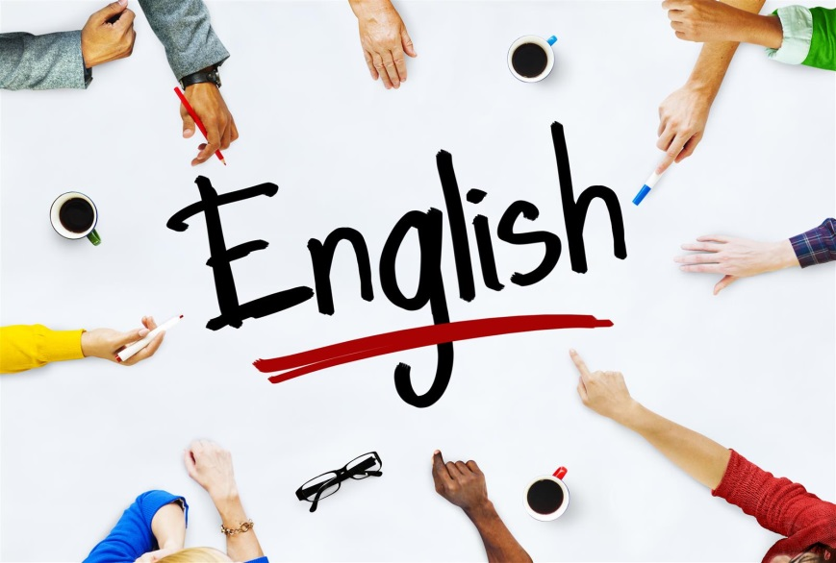

Учитель:
Сатыбалдина Жанна Аитбаевна

2020 – 2021 оқу жылы
2020 – 2021 учебный год
Lesson: School items |  |  |  | School: № 23
Date: 8.11.2020 |  |  |  | Teacher name: Satybaldina Zhanna
Class:2 |  |  |  | Number present: absent:
Learning objectives: |  |  |  | 2.L1 understand a range of short basic supported classroom instructions  2.UE2 use cardinal numbers 1 -50 to count
Lesson objectives: |  |  |  | All learner will be able to:  Name school items  Most learners will be able to:  Use plural and singular forms  Some learners will be able to:  make up sentences with there is/are
Success criteria |  |  |  | Learners use the construction there is/are correctly and use names of school items
Value links |  |  |  | Cooperation and mutual respect  Learning-centered activities
Cross curricular links |  |  |  | Math
ICT skills |  |  |  | Using pictures, working with URLs (by the teacher)
Previous learning: |  |  |  | Counting and measuring
Planned timings | Planned activities |  |  |  | Resources /Materials
The beginning of the lesson  (3 - 4 min.)  (2 - 3 min.) | Greeting (Hello)  T: What day is it today/yesterday/tomorrow? What season is it now? What date is it today?  Setting the aim:  Look at the pictures. What is our topic?  Look at the criteria |  |  |  | Pictures of school items  Aim, criteria at the board  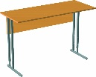  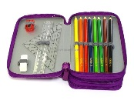
 | Warming- up:  Reading: trainer/sportsman  Collect c/s |  |  |  | ea - cards
The middle of the lesson  (3 – 4 min.)  (12 – 15 min.)  (2 - 3 min.)  (5 - 10 min.) | The ABC:  1)revising Gg-words  2)What letter is it? What sound? T asks Ss pointing at the studied letter)  What’s this? (pictures)  Read the words  Open c/s, write the date / the letter/ words  Checking up h/w:  1)oral checking  2)fill in the gaps – 2 min  *Switch check  Introducing new vocabulary:  1)Introducing and oral practice  2) Reading and marking rules  3)Studying and gluing the cards  4)IW: AB p. 21 ex.1 – 4 min.  *Self check |  |  |  | Letters and sounds: Gg; pictures + words on the board  Pictures of school items *2  Words with gaps on the board:  1. p_n  2. penci_  3. ru_er  4. bo_k  5. school_ag  6.rubb_r  Cards with new words:  Teacher, classroom, pencil case, desk, sharpener
 | GW:  Put number in a correct order  *self check |  |  |  | Numbers cards
 | Introducing new grammar:  1)Introducing there is/are + short forms  2)IW:do the task-5 min  *Self check + t’s written feedback  There is – используется в единственном числе  There is a pen.  There are – используется во множественном числе  There are five pens. |  |  |  | Worksheets (counting school items + there is/are)  Fill in the gaps with is or are:  1. There ____ a big yellow book  2. There ____5 small green sharpeners  3. There ____ a pink schoolbag  4. There _____3 red and blue rubbers  5.There ____ a small desk  6. There _____seven rulers
The end of the lesson  (2 – 3 min.) | H/t: learn words, to write words, PB p.38 ex.12  Reflection  Saying goodbye
Additional information
Differentiation – how do you plan to give more support? How do you plan to challenge the more able learners? |  | Assessment – how are you planning to check learners’ learning? |  |  |  | Cross-curricular links/Health and safety check/ICT links/  Values links
More capable Ss are supposed to give some help weaker ones while working in groups and while circle and pair work |  | Self check  ‘Thumbs up’ check  T’s oral feedback |  |  |  | Life long learning; video and presentation; safe environment;  Math
Reflection
Were the lesson objectives/learning objectives realistic? |  |  | Yes, the lesson objectives were realistic
What did the learners learn today? |  |  | - School items  - There is/ There are
What was the learning atmosphere like? |  |  | Friendly
Did my planned differentiation work well? |  |  | Well

