Short-term plan  Lesson: “Analyzıng the ingredients of a successful speech. Idioms.” |  |  |  | College:
Date: |  |  |  | Teacher name: Оспанова Рабиға Асановна
Group: ҚТЖӘ-22-9-2 |  |  |  | Number present: |  | absent:
Theme of the lesson: Analyzıng the ingredients of a successful speech. Idioms.
Learning objectives |  | - use imagination to express thoughts, ideas, experiences and feeling  - understand specific information and detail in extended texts on a wide range of familiar and unfamiliar general and curricular topics  - recognize the attitude, opinion or tone of the writer in extended texts on a range of more complex and abstract general and curricular topics
Lesson objectives |  | All learners will be able to  identify some specific information and key ideas from the text and use some target vocabulary to recount some main points from the story
Most learners will be able to
identify most specific information and some key ideas from the text and use a range of target vocabulary to recount some main points from the story

Some learners will be able to
identify all specific information and most key ideas in texts and use a range of target language to express views and comment on views of others with little support
Assessment criteria |  | - Understand the specific information given in the video  - Analyze the successful speech from the video  - Plan and write successful speech about "Climate change and the impact of society on it"
Previous learning |  | Use of English
Plan
Part of the lesson/Time | Teacher’s activity |  | Student’s activity |  | Assessment |  | Resources
Beginning of the lesson  Warming-up  Whole class | Organization moment:  1.Greeting.  2. Organization moment.  Teacher gives strings students to say warm words to each other. |  | Ss should continue saying good words, wishes to each other passing the string.  Be happy  Be healthy  Save your family  The aim: develop students speaking skills and helps to break down their shy habits.  Efficiency:By passing the string Ss feel good atmosphere. |  | After doing the actions T tries to award active Ss.«The praise» method is used to evaluate Ss with phrases like:  “Good job!  Well done!” |  | Envelop with shapes  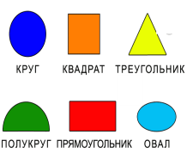
Main part | Lead-in activity  The teacher may ask some questions to help students to guess the topic of the lesson.  - What traits of character does a person need to make a successful speech?  - What are the ingredients of a successful speech?  - What fear a person may experience when he/she attempts to make a speech?  A Teacher’s feedback is provided through delayed-error correction.  Discussion. Active method “Discussion”  The teacher introduces the lesson objectives.  Then the teacher shows learners a question on a PPT slide to discuss:  • Do you know of any great public speakers?  The teacher suggests watching a video of Leonardo Dicaprio speech "climate change"  Pre-listening. Active method “Brainstorming”  Ss make three predictions about what the video will be based on the title.  (W) General questions.  - What do you know about climate change?  - What is the impact of society on climate change?  Differentiation. Teacher support for students  The teacher devides the students into 3 groups by counting 1-2-3 and introduces some new vocabulary before listening. The teacher drills the pronunciation of the vocabulary.  TASK-1 Listening task.  First listening. Active method "Group buzz"  The listening task is a video and it will be easy for auditory and visual learners to fulfil the task. In addition, a teacher can differentiate by switching on/off subtitles for the video.  Second listening. Active method “Unfinished sentences”.  While second listening fill in the detailed information  1. Billions of others around the world want to solve our _____________.  2. We’re seeing new and undeniable climate events, evidence that ___________________.  3. We are seeing __________________, increased temperatures  3. None of this is rhetoric, and none of it is hysteria. ________________  4. I have seen cities like _____________ by industrial pollution.  5. Ancient __________ in Greenland and the Arctic are disappearing  6. Ancient glaciers in Greenland and the Arctic are _________________ than ever.  7. I've seen an unprecedented drought in _________________.  8. Clean air and water, and a ____________ are inalienable human rights.  Self-assessment  Description Points  1 climate crisis 1  2 accelerated climate change 1  3 extreme weather events 1  4 It is a fact. 1  5 Beijing choked 1  6 glaciers 1  7 disappearing faster 1  8 America and California 1  9 liveable climate 1  Total 9  Differentiation.  Teacher prepare interview questions in advance for students who need support, students who do not need support can use their own questions.  Questions for students in need of support:  - What is the video about?  - What did Leonard Decaprio say?  - What would you say about Leonard Decaprio's idea of a rise in temperature?  - Do you agree with the opinion about the pollution of cities? What do you think?  - Do you agree with Leonard Decaprio's idea of drought and air pollution? How do you think is this situation harmful?  Students can ask additional questions themselves.  The observer student evaluates the successful speech on the following questions, provides feedback.  TASK-2. Flashcards  After finishing the listening tasks teacher asks one member of the team and suggests to choose one flash card to practice the successful speech.  Materials: Flascard+useful phrases+special worksheet  “Comments” method is used to find out was the lesson clear or not. Use the stickers.  TASK-3. Digital task -Wordwall  Teacher should show the QR code of the task. And after finishing they can see their results  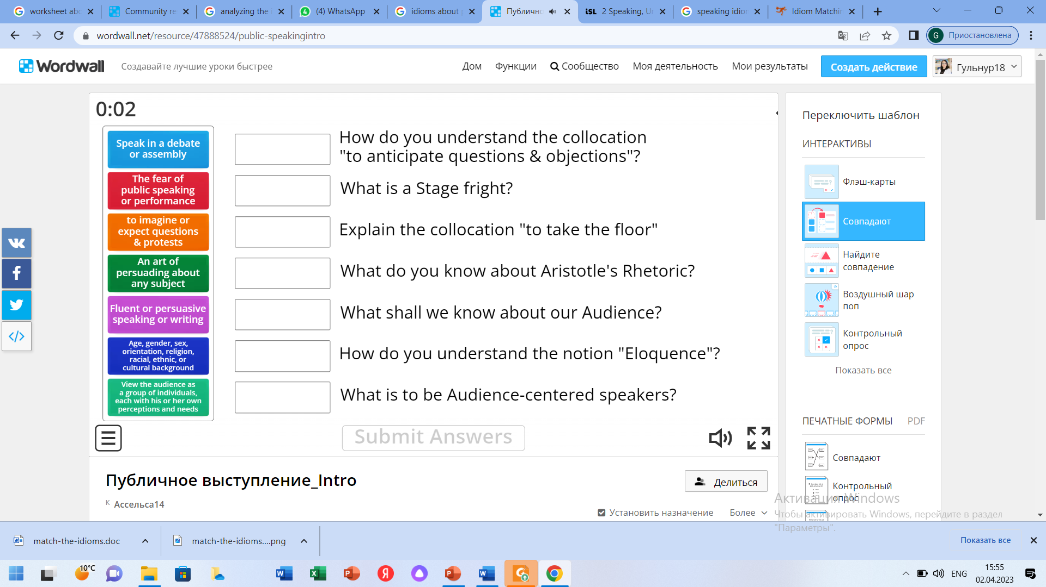  TASK-4 Match the Idioms  Teacher asks to translate the idioms by theirs meaning and complete the sentences  Feedback to each other by the method wish lamp(тілек шамы) |  | Then students should answer the questions  Students should give any information about public speakers  Students view an excerpt of the video on the topic "Climate change". After watching the video, students using the active learning method "Group buzz" discuss what they have heard in a short time.  Answer general questions.  Students check their completion and then write the main idea in three sentences. The teacher asks the students to read what they have written.  One member of the group can comment  Active method “Interview”  Studen should make up short interviews on the watching video.  The work will be in threes. One gets an interview, the other gives an interview. The third student listens to the interview, evaluates the successful speech, and then tells your own thoughts.  Student choose the flash card and work with group  Then one student should make a speech by chosen theme of the flashcard and second member of the opposite group should assess and give feedback.  Students scan the QR code of the task and complete it.  Students should translate the idioms and complete the task |  |  |  | Whiteboard  PPT  https://youtu.be/Si9nPPtza5k  https://youtu.be/Si9nPPtza5k  https://wordwall.net/resource/47888524  PPT, worksheet
End of the lesson.  Reflection  Individual work:  5 min. | Quiz show with word wall -conclusion game    For reflection teacher asks students to take the special stickers and evaluate the lesson by putting their stickers to necessary Island. |  | Students can play quiz show and make a conclusion of learned materials  Ss use their stickers of today’s lesson. Commentaries, wishes.  Aim:To know how many Ss got the theme.  Efficiency:learn to comment somebody using simple sentence.  Differentiation:«Conclusion» method is used to finish the lesson. |  | Feedback:  “The praise” method  “Good job!  Well done!” |  | https://wordwall.net/resource/12284477

