«Жамбыл облысы әкімдігінің білім бөлімінің Әлихан Бөкейханов атындағы №1 гимназиясы» коммуналдық мемлекеттік мекемесі
Коммунальное государственное учреждение «Гимназия №1 имени Алихана Бокейханова отдела образования акимата Жамбылской области»
Municipal State Institution «Gymnasium No. 1 named after Alikhan Bokeikhanov of the Department of Education of the Akimat of Zhambyl region»
_________________________________________________________________
Қысқа мерзімді жоспар / Краткосрочный план / Short-term lesson plan

Subject | Unit 3. Values
Teacher’s name | Maiko Nurdana Nurlankyzy
Date | 29.11.2021
Grade  5 G’ | Present: | Absent:
Student’s Book | English Plus 5/Excel 5
Theme of the lesson | Good actions we value
Learning objectives | 5.2.2.1 understand an increasing range of unsupported basic questions which ask for personal information  5.4.6.1 recognize the attitude or opinion of the writer in short texts on a limited range of general and curricular topics
Lesson Objectives | - understand the main information from the text  - answer the questions according to the text  - distinguish what is bad and good

Сабақтың барысы/ Ход урока / Plan:
Lesson steps / timing | Teacher’s activities | Students’ activities | Assessment | Resources
Start  7 min | Organization moment:  Teacher greets students  -Good afternoon  -How are you?  Warm up  “Hangman”  One player thinks of a word or phrase; the others try to guess what it is one letter at a time. The player draws a number of dashes equivalent to the number of letters in the word. If a guessing player suggests a letter that occurs in the word, the other player fills in the blanks with that letter in the right places. If the word does not contain the suggested letter, the other player draws one element of a hangman’s gallows. As the game progresses, a segment of the gallows and of a victim is added for every suggested letter not in the word. The number of incorrect guesses before the game ends is up to the players, but completing a character in a noose provides a minimum of six wrong answers until the game ends. The first player to guess the correct answer thinks of the word for the next game. | S-s respond to greeting  S-s try to guess the word | Oral assessment:  Excellent!  Good!
Middle  33 min | Demonstration method  Teacher shows code to find today’s theme  20-12-12-23 26-24-7-18-12-13-8 4-22 5-26-15-6-22  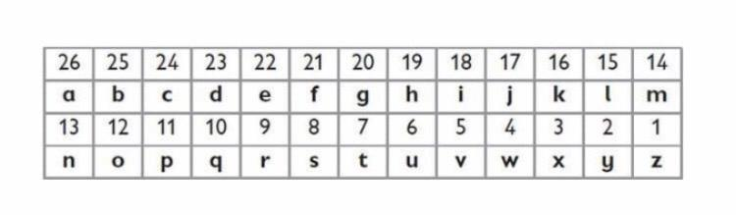  Yes, you are right! Today’s our new theme is Good actions we value.  T introduces with LO of the lesson.  Students are divided into 3 groups by choosing random cards with colors.  Pre-listening  Introducing with vocabulary  Working with new words  Find the synonyms  Listening  Post-listening  Task 1.Mark the sentences TRUE or FALSE  - The mouse was very afraid.  - A mighty lion, tired from hunting all day, lay down to take a nap.  - The lion struggled to free himself, and he did it.  - His angry roars rumbled through the forest as he became upset and afraid.  - Some mice that lived at the foot of the tree passed by the sleeping lion to return to their home.  - The lion and the mouse were friends forever after.  Physical exercise. “Simon says”  Task 3.  Answer the questions  - What is the moral of the story?  Good deeds are rewarded. And what does it mean? How do you think?  - Is the lion bad?  - Is the mouse kind?  Look at the pictures. What is depicted here?  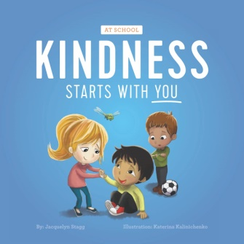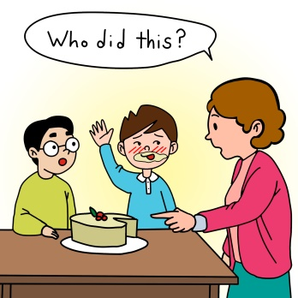  - What qualities of your friend do you value?  Task 2  Write good actions/deeds and bad actions/deeds  Think about what a good friend and a bad friend do. Divide them into two columns.  You are given cut pieces of questions. Each group should collect their questions and find answers to them. After that, you will ask questions to each other.  Task 4.  - When did the lion wake up?  - Why did the mice climb over the lion?  - How did the lion catch the mouse?  - How did the lion get trapped?  - How did the mouse help the lion?  - What did the lion and the mouse learn? | S-s try to guess the theme  S-s read new words  S-s find the synonyms  S-s read and listen  S-s mark the sentences  S-s answer the questions  S-s divide the actions  S-s collect questions and find answers | Oral assessment  You are right!  Good!  Not bad!  Brilliant!  Oral assessment  You are right!  Good!  Not bad!  Oral assessment  You are right!  Good!  Not bad!  Criterial assessment  Descriptor:  A learner  -distinguishes good and bad actions  - speaks with the correct pronunciation  Criterial assessment  Descriptor:  A learner  -collects the questions correctly  -finds answers  - answers questions from other groups  -speaks with correct pronunciation | Cards  https://www.youtube.com/watch?v=iPybpc-xuG0  Worksheet  Worksheet  Pictures
End  5 min | Reflection  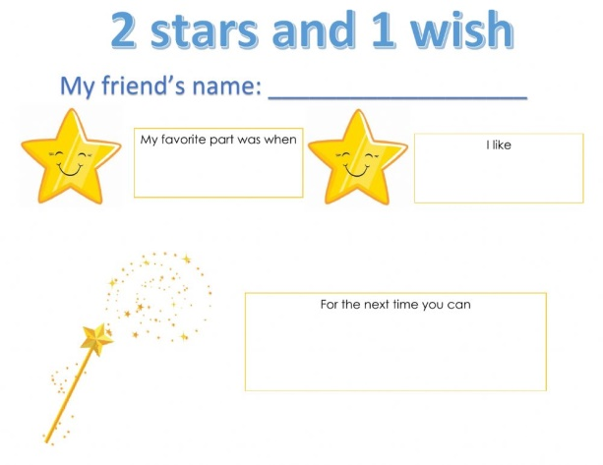  Homework: Learn new words, and make up 3 sen. with new words | S-s write their homework. | Thank you for active work!

Additional information
Differentiation – how do you plan to give more support? How do you plan to challenge the more able learners? | Assessment – how are you planning to check learners’ learning? | Health and safety check
Reflection  Were the lesson objectives/learning objectives realistic?  What did the learners learn today?  What was the learning atmosphere like?  Did my planned differentiation work well?  Did I stick to timings? What changes did I make from my plan and why? | Use the space below to reflect on your lesson. Answer the most relevant questions from the box on the left about your lesson.

