Short term plan

Term 3  Unit 3 “Earth and our place on it” |  | School: № 15
Date: |  | Teacher’s name: Beisenbayeva D.K.
Grade 9 |  | Number present: | Number absent:
Theme of the lesson: |  | Environmental problems
Learning objectives(s) that this lesson is contributing to | 9.4.5.1 deduce meaning from context in extended texts on a range of familiar general and curricular topics  9.3.7.1 use appropriate subject-specific vocabulary and syntax to talk about a wide increased range of general and curricular topics  9.1.6.1 organize and present information clearly to others;  9.2.5.1 recognize the opinion of the speaker(s) in unsupported extended talk on a wide range of general and curricular topics;
Lesson objectives | All learners will be able to:
- Recognize and use nouns related to the environment
- Come up with some examples of environmental problems
- Understand the main idea of the text
- Complete KWHLAQ chart about the topic
 | Most learners will be able to:
- Recognize and use specific vocabulary related to the environment
- Identify some environmental problems and find their solutions
- Understand the specific information of the text
 | Some learners will be able to:
- Express their opinions about the environmental problems
- Present information to others
Assessment criteria | Complete KWHLAQ chart  Read and comprehend the text  Demonstrate the ability to participate in a conversation  Apply topic related vocabulary in speech appropriately arranging words and phrases into well-formed sentences  Present and share ideas with classmates
Level of thinking skills | HOTS
Value links | Respecting and protecting the environment
Cross curricular links | Ecology, Geography, Biology, Chemistry, ICT
Previous learning | Use of English: Modals
Use of ICT | Smart Board, Projector
Health and Safety links | Switch off the active board if you do not use it.  If students are tired, do physical exercise with them.  Open the window to refresh the air in the classroom during the break.

Plan
Planned timings | Planned activities | Resources
Beginning of the lesson  1 min  2 min  3 min | Preparation: Before the beginning of the lesson SS are divided into 3 groups of 4 by using pictured cards (pollution, solar energy, recycling)  Leading-in stage  The lesson greeting.  The teacher sets the lesson objectives, letting students know what to anticipate from the lesson.  Warm up.  1.[W] Begin lesson by telling students that they will be shown a series of photos on PPT. They should name the individual photos and think about what these photos have in common. This discussion should lead to students identifying these photos as examples of environmental problems. Ask students if they can think of a term that groups them all: environmental problems  2. [I,W] Teacher asks SS to complete KWHLAQ chart about environmental problems. Some SS share their ideas (1 from each group). SS will complete the 4th and 6th columns of the chart at the end of the lesson. Look at the Appendix № 1.  KWHLAQ  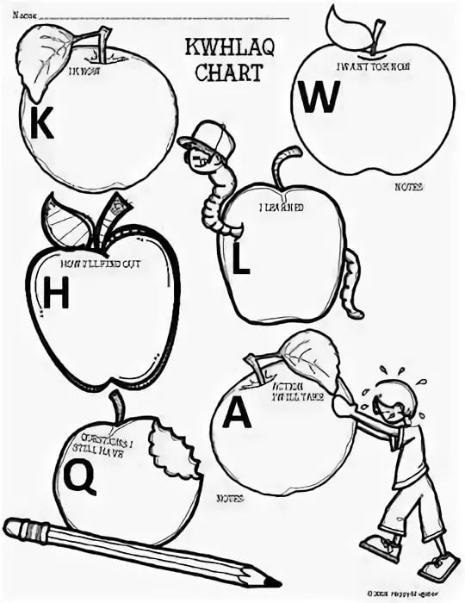  Formative Assessment: teacher gives SS positive feedback on their answers. | https://www.desmogblog.com/sites/beta.desmogblog.com/files/blogimages/Benxi_Steel_Industries.jpg  http://jecslimited.com/home/wp-content/uploads/2016/05/Power-plant-using-renewable-solar-energy.jpg  https://img2.freepng.ru/20180604/ufz/kisspng-paper-recycling-symbol-recycling-bin-glass-recycli-recycling-symbol-5b15e234237938.6638478315281608201453.jpg  Pictures of EP  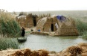  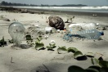https://www.cmu.edu/cee/news/news-archive/2017/2017-images/2017-images-powerindex.jpg  http://img12.nnm.me/3/4/1/e/f/1d2016d0e6dc9ffeb8b2f9bf627.jpg  https://cdn.fishki.net/upload/post/2019/06/05/2999573/smoke-258786-1920.jp  https://www.theguardian.com/environment/gallery/2016/apr/05/environmental-photographer-of-the-year-competition-nature-photography#img-1  https://www.theguardian.com/environment/gallery/2016/apr/05/environmental-photographer-of-the-year-competition-nature-photography#img-2  PPT slides  https://i.pinimg.com/736x/03/c0/8f/03c08f8be9b073d6527be021c53e0aee.jpg  Hand out 1
Middle of the lesson  5 min  10 min | Reading  1. Pre-reading task [ W, I ]  [I,W] Task. Teacher introduces the new vocabulary and definitions and offers SS to practice the pronunciation of new words and useful phrases (chorally and individually). Look at the Appendix № 2.  Topical vocabulary:  Endangered species a species of plant or animal that is in danger of becoming extinct.  Evolution the continuous modification and adaptation of organisms to their environments through selection, hybridization, and the like.  Extinct no longer existing, as an animal species.  Greenhouse effect the warming trend on the surface and in the lower atmosphere of a planet, held by scientists to occur when solar radiation is trapped, as by emissions from the planet.  Habitat the natural environment of a plant or animal.  Insecticide a substance used to kill insects.  Atmosphere the mass of gases surrounding the earth or any other celestial body.  Ozone oxygen in the form of molecules with three atoms, created by exposure of oxygen to electrical discharge or ultraviolet radiation, having a sharp smell, and being an effective oxidant for use in bleaching and sterilizing.  Poacher one who illegally hunts on another's property.  Pollution contaminating material that pollutes.  Smog a haze caused by the effect of sunlight on foggy air that has been polluted by vehicle exhaust gases and industrial smoke. Biosphere the part of the earth and its atmosphere in which living organisms can exist.  Conservation the act of preserving and protecting from loss, destruction, or waste.  2.While-reading task: ‘Jigsaw’ reading strategy [I, G, W]  There are 3 laminated cards with topics: Pollution, Alternative energy, Recycling. Individuals will read cards and share the information with their group. Look at the Appendix № 3.  • Teacher gives each group 1 card. Explain they have to read and summarize the main information from their text. They should make notes to help them to remember. Monitor and help understanding if necessary. (Additional option for a higher level class: ask them to find two main problems or solutions in each card).  • Ask learners to put their cards under their books and regroup the learners (so the new group has one member from each of the original groups). Ask students to explain their topics to each other and make notes. (Teacher should let them know there is going to be a quiz later). They should write in note form. Only interfere if they really can’t understand.  Differentiation by support:  Weaker students will be supported by stronger students.  Peer assessment:  SS assess each other using the assessment sheet.  -explains topic to other students  group (coloured paper helps). Cut up the questions. The teacher should keep the piles of questions. (shuffling the questions prevents cheating later on and encourages retaining information if they do overhear). | Hand out 2  https://www.it.iitb.ac.in/~vijaya/ssrvm/worksheetscd/getWorksheets.com/Science/environment  Hand out 3  https://www.teachingenglish.org.uk/sites/teacheng/files/Environmental%20problems_worksheets.pdf
10 min  7 min | Descriptors  A learner:  - reads and comprehends the text  -shares information with others  3. Post-reading task [I, G]  The quiz will test the learners’ understanding of the texts and ensure they share information from their reading texts. The quiz will be set up like a race and ought to be competitive and so allow groups to name themselves, draw up a score board etc. Look at the Appendix № 4.  Make copies of the quiz for one per group (colored paper helps). Cut up the questions. The teacher should keep the piles of questions. (shuffling the questions prevents cheating later on and encourages retaining information if they do overhear).  One member of each group comes forward and takes one question from their colored pile.  • They return to their group and discuss the answer and write it down.  • Once the group has written their answer a runner should take it back to the teacher (forming a queue at the teacher’s desk)  • The teacher should check the answer and either accept the card and give another question or reject the answer and send the runner back to the group with the same question (feedback such as there’s one more important thing missing helps).  • The winning group is first to complete all questions correct. They can then help check the answers to the other teams until most of the questions have been done by all teams.  • Finish by giving everyone a copy of all the articles. Depending on time, you could give a few minutes to skim through them.  Differentiation by support:  Weaker students will be supported by stronger students.  Peer assessment  SS assess each other using the assessment sheet.  Descriptors  A learner:  - works in group  -answers the question  -discusses in a group  4. Vocabulary task [I, P]  Environment Cryptogram. Look at the Appendix № 5.  Instructions: Unscramble the words by placing the correct letter in the shaded boxes. Use the numbered boxes to complete the answer to the riddle.  Differentiation by support:  Weaker students will be supported by stronger students.  Self-assessment  SS assess themselves by using assessment sheets. | Hand out 4  https://www.teachingenglish.org.uk/sites/teacheng/files/Environmental%20problems_worksheets.pdf  Hand out 5  https://www.it.iitb.ac.in/~vijaya/ssrvm/worksheetscd/getWorksheets.com/Science/environment
Descriptors
A learner:
-places the correct letter in the shaded boxes
-uses the numbered boxes to complete the answer to the riddle
-uses vocabulary correctly

End of the lesson  2 min | Feedback  KWHLAQ chart.  Teacher comes back to lesson objectives and finds out together with SS what they have learned and what new questions they have.  Home task:  *Choose one environmental problem and find a solution. Make a poster and present to the class.  Find out some information about another environmental problem and tell to the class | Hand out 1
End  1min | Feedback: Teacher asks students what task was difficult to them and which pair worked well.

Hand out 1

Hand out 2
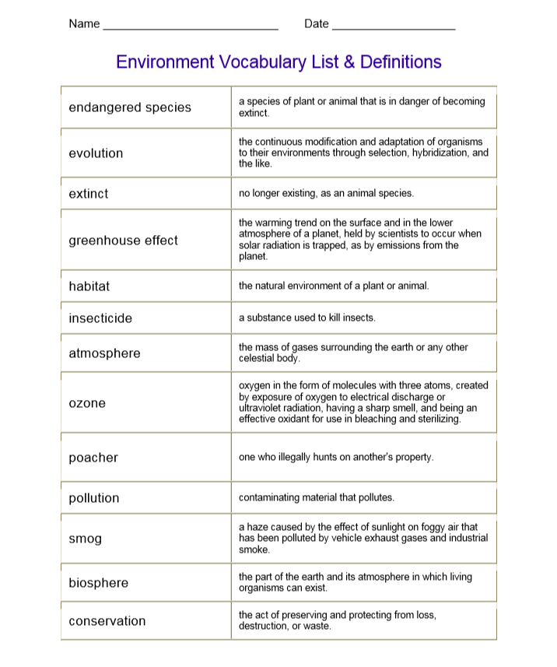

Hand out 3

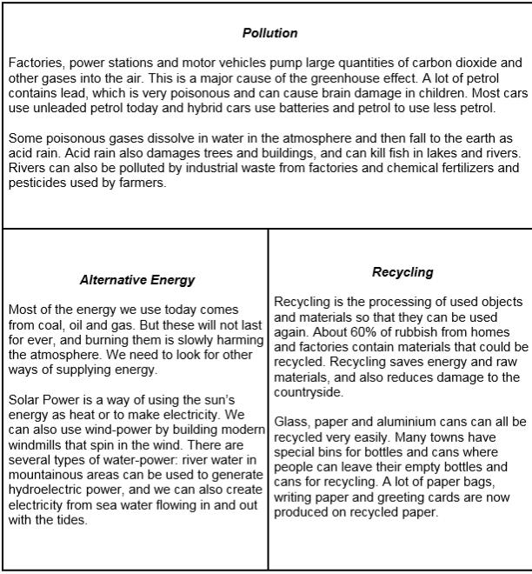

Hand out 4
- What alternative forms of energy do you know?
- What is acid rain?
- What is recycling? How does it help the environment?
- What is the Greenhouse effect?

Hand out 5
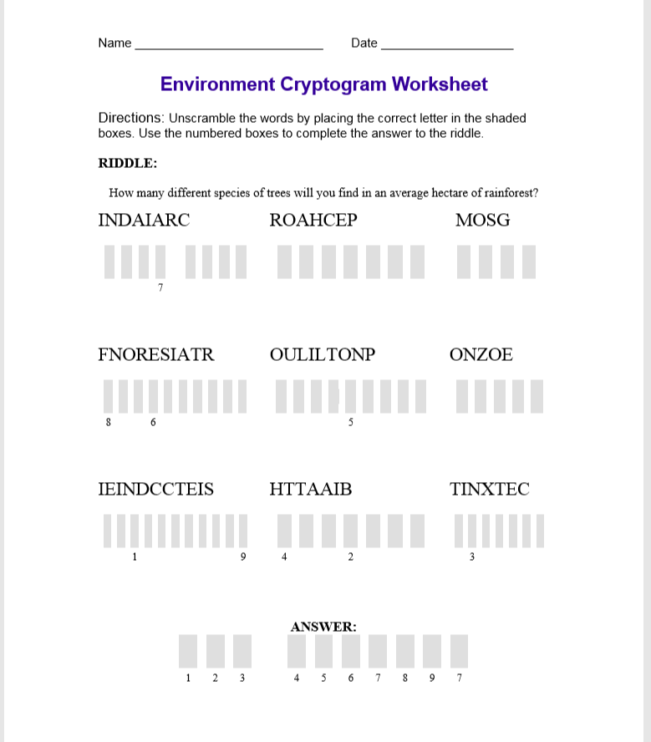

Assessment sheet 1 Grade 9
……………………………………(name) can: Theme: Environmental problems. Pollution/Energy/Recycling . While-reading task
 | very well | OK | not very well
Reads and understand the main idea of the text
Share information with others clearly

Assessment sheet 2 Grade 9
……………………………………(name) can: Theme: Environmental problems. Pollution/Energy/Recycling . Post-reading task
 | very well | OK | not very well
Works in group
Answers the question
Discusses in a group

Self-assessment sheet 3 Grade 9
I can: Theme: Environmental problems. Vocabulary task
 | very well | OK | not very well
uses new vocabulary and useful phrases according to the topic
places the correct letter in the shaded boxes
uses the numbered boxes to complete the answer to the riddle

