**Short term plan**

|  |  |  |  |
| --- | --- | --- | --- |
| **Unit of a long term plan: Drama and Comedy** | | **School: 144** | |
| **Date:**xx.xx.xxxx | | **Teacher name: Veronika Samsonova** | |
| **Grade: 6** | | **Number present:** 16 | **absent: -** |
| **Lesson title** | Types of films | | |
| **Learning objectives** | 6.4.3.1- understand the detail of an argument on a limited range of familiar  general and curricular topics, including some extended texts  6.3.2.1- ask simple questions to get information about a growing range of general topics | | |
| **Lesson objectives** | * identify details in a text * ask simple questions using correct forms of Present Perfect and Past Simple * use appropriate intonation while asking questions | | |

|  |  |  |  |  |
| --- | --- | --- | --- | --- |
| Stages / Time | Teachers actions | Students actions | Assessment | Resources |
| Beginning of the lesson  *Greetings*  *2 min*  *Warm-up*  *5 min*  *Brainstorming*  Main part  *Pre-reading*  *3 min*  *Predicting*  *3 min*  *Pre-teach vocabulary*  *5min*  *While-reading*  *10 min*  *Post-reading*  *12 min*  *Speaking task*  *Homework* | Teacher greets the pupils:   * Good afternoon! * How are you?   Teacher shows the pictures  What is the theme of our lesson?  Teacher asks the pupils to work in pairs and answer the question:   * What films do you like? Why?   Teacher shows a short video about film “Kyzgaldak”.  Teacher asks questions  What is this film about?  Who are the main characters?  Teacher presents new vocabulary using context clues  director (definition clue)-a person who supervises the actors in a film  release(definition clue)-make a film  herdsman(picture)-    give up(synonym clue)-lay off  introduce (definition clue)-bring for the first time  create (synonym clue)-produce  cast(definition clue)- team of actors  performance (definition clue)-an act of presenting a film  Teacher asks concept questions to train the new words  1. Does the director supervise the actors in a film?  2. Is a herdsman look after the sheep?  3. Have you ever introduced anything?  4. Is the cast team of actors?  5. Have you ever given up your ideas?  After that, teacher asks pupils to read the text for more details and decide if the statements are True (T) or False (F).  1)Kyzgaldak won an Oscar. 2)Assa's dream is to be a herdsman. 3)Assa marries Kyzgaldak. 4)The film is set in a city. 5)The actors are not very good. 6)Askhat Kushinsherekov has the main role.  Teacher asks the pupils to give 2 reasons of going to see this film  «Think and Share » method  develops reading skills and critical thinking skills  **Differentiation:**  «**Verbal support**» method helps pupils to use new words in the sentences.  Teacher asks the pupils to work in pairs, discuss and  choose the film to go and watch.  -What are you going to see?  -What kind of film is it?  -What is it about?  Then teacher asks the pupils to ask and answer the questions like in example.  1. speak to a famous person?-Who?- Askhat Kuchinchirekov  Have you ever spoken to a famous person? Who did you speak to?  **Differentiation:**  «Think, pair, share» method develops pupils’ speaking and listening skills.  Teacher asks the pupils to prepare the retelling of the text at home. | *Pupils respond*  *Pupils guess the type of the film*  *Pupils guess the theme of the lesson*  *Pupils discuss in pairs their favourite types of films*  *Pupils watch the video*  *Pupils answer the questions*  Pupils answer the questions  Then the pupils repeat the words after the teacher and write them in their vocabularies  Pupils scan the text and say if the statements are True (T) or False (F).  **Differentiation:**  Strong pupils correct false sentences.  **Differentiation:**  Strong pupils explain the reasons.  Low motivated pupilsfind the words and expressions in the text.  **Differentiation:**  All pupils work in pairs and discuss the films.  Strong pupils support the students with different language competence.  **Differentiation:**  Strong pupils ask and answer the questions like in example. Then one member of each pair goes to talk to another pupil.  Low motivated pupilsfind the sentences in Past Simple and Present Perfect in the text.  **Differentiation:**  Low motivated pupilsread the text and choose the right word. | Descriptor :  A learner identifies types of films-1point  Descriptor :  A learner makes sentences about types of films-1point  Peer assessment.  Descriptor :  A learner answers the questions correctly -1point  Verbal assessment  Descriptor:  A learner identifies  details in a text -1point.  A learner corrects false sentences – 1 point.  Descriptor:  A learner gives 2 reasons-1point.  A learner finds the words and expressions in the text – 1 point.  Descriptor:  A learner chooses the film and gives the explanation -1 point  -speaks on the theme-1 point  Descriptor:  A learner makes up 4-5 simple questions – 1 point;  -answers the questions correctly -1 point.  Descriptor:  A learner with different language competence finds the sentences in Past Simple and Present Perfect -1 point.  Descriptor:  A learner retells the text:  - using at least 10 sentences;  -uses topical vocabulary;  -uses the verb tenses correctly – 5 points.  Low motivated pupilschooses the words correctly – 5 points. | Student’s book. Excel for Kazakhstan Virginia Evans, Jenny Dooley, Bob Obey Express publishing p 46  Appendix 1  Video  <https://www.youtube.com/watch?v=7ZUNoUTiNUw>  Student’s book. Excel for Kazakhstan Virginia Evans, Jenny Dooley, Bob Obey Express publishing  Appendix 2  Student’s book. Excel for Kazakhstan Virginia Evans, Jenny Dooley, Bob Obey Express publishing.  Appendix 3 (ex.1)  Student’s book. Excel for Kazakhstan Virginia Evans, Jenny Dooley, Bob Obey Express publishing  ex7 p 47  Appendix 3(3)  Appendix 3(2) |
| *Ending the lesson*  *Reflection*  *5 min* | Teacher asks the pupils to stick their stickers to the Success Ladder | Pupils show their knowledge with the stickers:  **Green**-I understood  **Yellow**-I have some questions  **Red**-I need help | Feedback:  Teacher gives the feedback on the lesson to the pupils. | Poster: Success Ladder |

Appendix 1

Types of films







# 

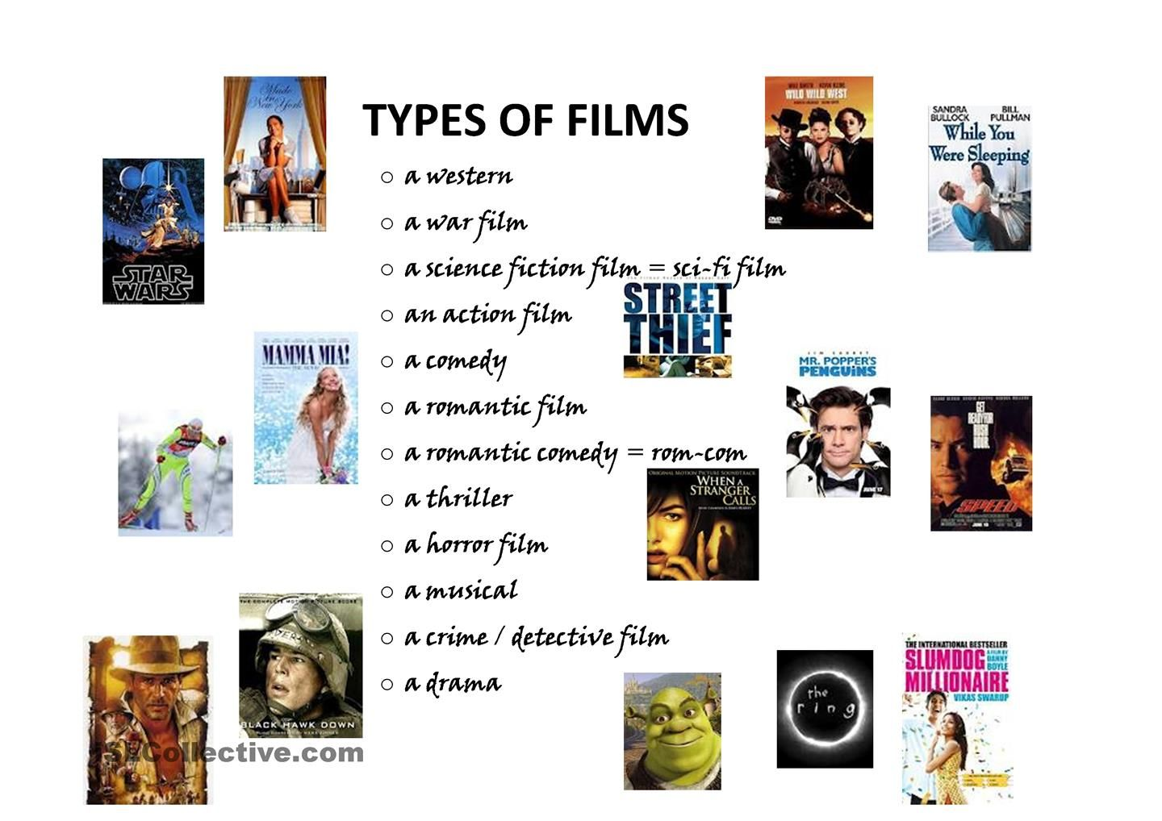





Appendix 2

Kyzgaldak  
In 2008, the Kazakhstani director Sergei Dvortsevoy released the drama film Kyzgaldak which has won many international awards. The story begins with Assa who lives in the countryside, far away from the other cities or towns. He used to be a sailor in the Russian Navy, but now he wants to become a herdsman and marry the only girl in the neighbourhood, Kyzgaldak. However, she's not interested because she thinks Assa's ears are too big! But Assa has big dreams and doesn't give up easily.​

The setting of the film is the Kazakh steppe and, it introduces the audience to the traditions of the Kazakh people. What is interesting about the film is that the actors created much of the  
dialogue while filming. The whole cast gives a brilliant performance. Askhat Kushinsherekov is excellent in the lead role as Assa.  
The best thing about Kyzgaldak is that you learn about life in rural Kazakhstan. Also, the film has lots of really funny moments. Don't miss it!

Appendix 3

**For strong pupils**

2. see any of the batman films? – When? – 2 years ago

3. go to see a play? – What? – Twelfth Night

4. visit a theatre? – When? – Last summer

5. go to a Arman cinema? – When? – 2 weeks ago

**For pupils with different language competence**

1. Find the words and expressions in the text:

выпустил драматический фильм, выиграл много международных наград, сейчас он хочет стать пастухом, Асса не сдается легко, он представляет зрителям традиции казахских людей, блестящее представление, не пропусти его.

1. Read the text and choose the right word.

Sergei Dvortsevoi released the _____________ ( drama, comedy, western, drama film).

Assa lives in the ________________ (city, countryside, town, forest).

He wants to become __________________(a sailor, a driver, a herdsman, a cowboy).

She thinks Assa’s ______________( teeth, ears , lips, eyes) are too big.

It introduces the audience to the traditions of Kazakh ___________(culture, people, steppe, history).

1. Find the sentences in Past Simple and Present Perfect in the text.