Unit 5 Creativity |  |  |  |  | School:
Date: 20.01.2020 |  |  |  |  | Teacher name:
Class: 5 |  |  |  |  | Number present: |  |  | Absent: 0
Lesson title |  | Art
Learning objectives(s) that this lesson is contributing to (link to the Subject programme) |  | 5 L1 understand a sequence of supported classroom instructions  5 L4 understand the main points of supported extended talk on a range of general and curricu8lar topics  5 S7 use appropriate subject-specific vocabulary and syntax to talk about a limited range of general topics  5 W3 write with support factual descriptions at text level which describe people, places and objects  5 UE3 use a growing variety of adjectives and regular and irregular comparative and superlative adjectives on a limited range of general and curricular topics
Lesson objectives |  | All learners will be able to use the main points of supported advanced communication on a range of general and curricular topics  Most learners will be able to explain and compare using vocabulary of general topic  Some learners will be able to explain and evaluate, using appropriate subject-specific vocabulary a limited range of general topics in making sentences
Level of thinking skills |  | Higher order thinking skills
Assessment criteria |  | makes up questions in order talk about main points of listening  uses vocabulary a limited range of common topics  evaluates and proves his mind
Value links |  | National unity, peace and harmony in our society
Cross-curricular links |  | Art
Previous learning |  | Unit revision about work past and future
Plan
Planned timings | Planned activities (replaces the notes below with your planned activities) |  |  |  |  |  | Resources
Start | Org. moment: Greeting learners  - Good morning!  - How are you today?  - I’m glad to see, you!  - Who is on duty today?  - What date is it today?  Warm-up: The aim of this warm-up repeat name of thing around us.  What is it?  Teacher chooses some pictures of object that are familiar to learners. Teacher shows learners a small portion of the picture. Get them to guess what the picture might be.  Learners will see pictures about different types of films, than they name their.  Descriptor: learners  Make up only word combinations  Make up full sentences  Answer for closed questions  Answer for open questions  Speak the name of film  This type of work are individual and in pair.  (T-S-S1…..) |  |  |  |  |  | 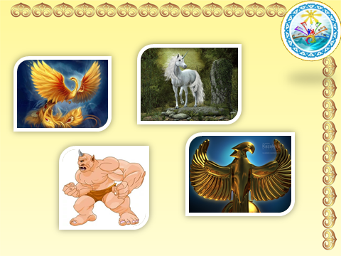  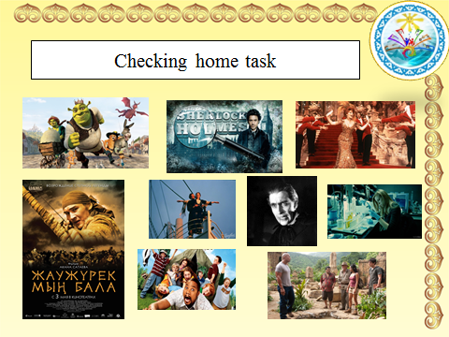
Middle | Task 1 for reading.  The aim of task to introduce the topic and stimulate interest in the text.  Students attention to the picture and ask if they know anything about the Samruk. Play the recording. Students listen and follow the text in their books and check if the questions were answered.  The Samruk was a magic bird. She lived in Kazakhstan long ago. Every year, she travelled to the Tree of Life out on the steppe. The Samruk had a nest high in the branches of the tree. In spring, a golden egg appeared in the nest. Some people say the egg contained the happiness and wishes of all the people in the world. All summer, the bird stayed in the tree, but the egg didn't hatch. Then, in winter, the Samruk disappeared, leaving her egg the nest A huge dragon lived in the underworld beneath the tree. He watched the Samruk leave and then he climbed up the trunk of the tree to the Samrulk's nest. He swallowed the golden egg and crawled back down to the underworld. The next spring, the Samruk returned to the Tree of Life again and another golden egg appeared. The same thing happened year after year on it, the Sun Aidahar, a dragon that lives at the foot of the Tree of Life swallows it. F good times follow difficult times in our lives. According to legend, Baiterek the Tree of Life. Every year the Samruk lays an egg The Samruk's story tells us that, just as day follows night and spring follows winter, good times follow difficult time in our lives  Suggested answer with key  1. Where did the Samruk go every summer? (To the Tree of Life out on the steppe).  2. What is the name of the Tree of Life? (The Baiterek)  3. What is the name of the Dragon who lives at the bottom of the tree? (Ajdahar)  Task 2. Mark the sentences T(true), F(false), DS (doesn’t)  - The tree of life was far away from the Samruk’s house …...  - The Samruk had a golden nest ………  - The Samruk was sad becouse her egg didn’t hatch …….  - The dragon wanted to eat the egg  Then the students change notebooks and check each other  Task 3. Listen and complete the fact file in your papers  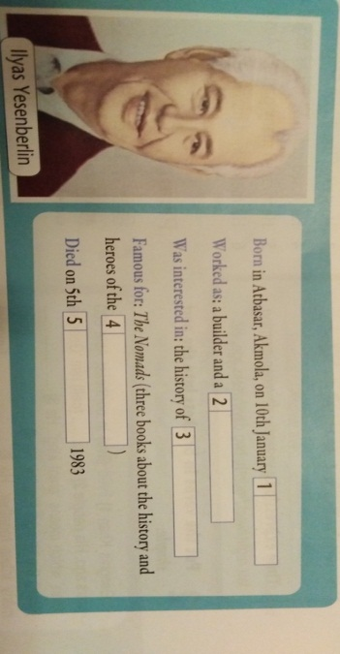  Then the students change papers and check each other |  |  |  |  |  | PowerPoint  CD-ROM  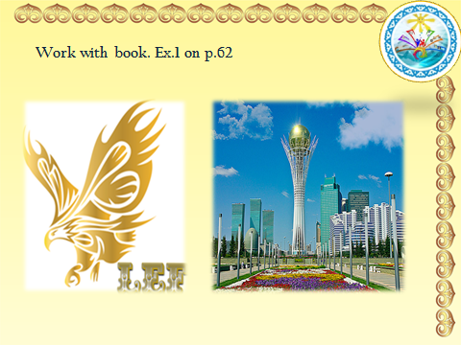  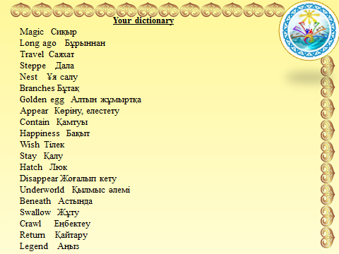  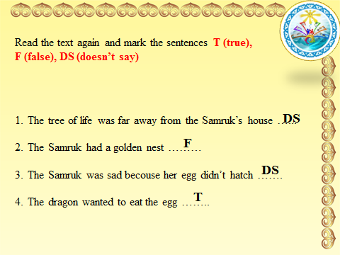
End | Feedback  Self-assessment: Hand signals |  |  |  |  |  | Hand signals  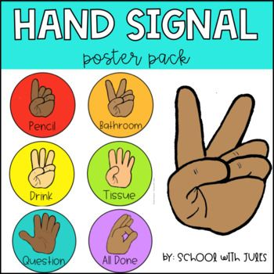
Additional information
Differentiation-how do you plan to give more support? How do you plan to challenge the more able learners? |  |  |  | Assessment -how are you planning to check learner’s learning? |  | Health and safety check
Students will support each other.  In the process of individual work, there is a joint discussion, an exchange of views, and a dialogue. |  |  |  | Question and answer (target and random). Evaluation of the response of a classmate.Keep teacher talking time to a minimum |  | The class is organized for individual and pair work.  ICT Skills to watch the video.  Ability to work in a group (mutual respect).  Answer questions and actively listen to others in the class discussion.  An interactive whiteboard was used to display videos, presentations, slides.
Reflection  What did the learner learn today?  What was the learning atmosphere like?  Did my planned differentiation work well? |  |  | Use the space below to reflect on your lesson. Answer the most relevant questions from the box on the left about your lesson.  Students got acquainted with new words. They remember new information about life tree.  The learning atmosphere was good.  Yes, it worked well.
Summery evaluation

What two things will go really well (consider both teaching and learning)?
1 -successful, in my opinion, will the stage of the lesson, all learners will involve in educational activities;
2 -no less successful will the discussion of the listening, learners will develop listening and speaking skills.
What two things would have improved the lesson (consider both teaching and learning)?
1It is necessary to continue working with students on staging open questions.
2 Involve learners in finding additional information for the lesson.

